

**Instructor: Dr. Taghreed Bagies**

Project Report

CPIT-455

**LifeQuest Website**

|  |  |
| --- | --- |
| Student Name | ID |
| Elaf Yousef Aloufi | 1911265 |
| Manar Mutlaq Altaiary | 1906775 |
| Joud Musharraf Alghamdi | 1905554 |
| Shireen Yahya Enani | 1806856 |

**Section:** C3A

**Group ID:** 4

**Table of Contents**

Abstract 4

Introduction 5

Problem statement 5

Proposed solution 5

Approach 6

Requirements and analysis 7

Functional requirements 7

Non-functional requirements 7

Preliminary risk assessment 8

Security requirements 10

Security Countermeasures 10

Use case Diagram 11

Use Case Description 12

Misuse case diagram 15

Misuse case Description 15

Design risk assessment 17

Design decisions 18

Dependable programming guidelines 18

Security guidelines 19

Security Testing 20

Database Design ER model 21

High-level Prototype 22

Graphical User Interface 24

Sign Up Page 24

Login Page 26

Add Post Page 27

View Posts Page 27

Instruction Page 28

About Us Page 30

Testing 31

Sign Up 31

Login 35

Add Post 38

View Post 41

View Post - Donate 41

View Post – Filter Posts 42

Update Account 44

Tools used 46

Lessons Learned 47

Obstacles 47

Future Work 47

Conclusion 48

Tasks distribution 49

GitHub 50

References 52

Abstract

Most patients who need blood transfusions post their requests for blood donors on their social media, which is a slow, inefficient approach, and might require direct contact between the donor and the patient.

LifeQuest is a medical Web-based Blood Donation System that aims to find blood donors for emergency patients who need blood transfusions. LifeQuest allows the patients to post requests with the specifications of the required blood in addition to some other information. Using the LifeQuest website, donors can search for patients who need blood to donate. Also, the website allows users to be either patients or donors without creating an account for each use.

This project aims to make blood donation requests as easy as possible and hasten the process (addition to/in order to) of searching for patients who need blood donations.

Introduction

In our daily lives, we come across people on social media who are looking for blood donors for their ill relatives. These people publish the patient's name and age and other information. As a result of the large number of messages we receive on our social media every day, these messages are often skipped or ignored by people. This method is ineffective for finding blood donors. Especially in emergency situations, the patient may not be able to wait long for a suitable blood donation. Furthermore, the patient may not accept the publication of their personal information. In order to speed up the process of finding donors, we developed a website that would enable people to share the message requesting blood donations.

The website aims to help users quickly locate a suitable blood donor. As well, all participants on the website will not be able to see the patient's personal information. Everyone can register and post a request for blood donations.

Problem statement

Many posts are created and shared daily on social media to request a specific blood type for emergency patients. The patients and their families spend a lot of time looking for potential blood donors with no health contraindications that may prevent blood donation. Using social media platforms to connect blood donors with recipients may be ineffective.

Proposed solution

Create [**LifeQuest**] web application that assists in finding potential blood donors for emergency patients easily by posting a request on the website to find blood donors that match their blood type. The post will include information such as blood type, and hospital name. To make it more secure, extra information will be sent via email to those who will donate. Besides allowing donors to schedule blood donation appointments for the selected patient via this website.

Approach

Scrum is an agile development methodology we used in the development and implementation of the project based on an iterative and incremental processes. It is an adaptable, fast, flexible, and effective agile framework.

This approach requires particular roles and responsibilities, including the scrum master, backlog, sprints, daily meetings, and retrospectives.

Scrum is executed in temporary blocks that are short and periodic, called Sprints. In each Sprint, we provided a complete result.

These sprints can be summarized as follows:

* **Sprint1:** Creating a Google drive, creating a Trello account, creating a GitHub repository, writing the problem statement and proposed solution, writing the requirements, and drawing the use case diagram.
* **Sprint2:** Preliminary Risk assessment, and Security Requirements.
* **Sprint3:** Finalizing Preliminary Risk assessment, finalizing Security Requirements, and Design risk assessment.
* **Sprint4:** Finalizing Design risk assessment, and adding any additional security requirements based on the design.
* **Sprint5:** Starting implementation (creation of database, creation of HTML files, creation of JSP files, and creation of Java classes), and ensuring the use of programming guidelines.
* **Sprint6:** Continue working on implementation.

Requirements and analysis

Functional requirements

* The user shall be able to register.
* The user shall be able to log in by username and password.
* The user shall be able to update their profile.
* The user shall be able to delete the account.
* The user shall be able to post a blood donation request including blood (type/donation type).
* The user shall be able to filter posts for blood requests by blood type, donation type, and/or location.
* The system shall only accept unique username from user.
* The system shall display blood donation instructions for donors.
* The system shall redirect donor to mail program to send an email to the patient when a donner clicks the donate button.

Non-functional requirements

* Usability: The website is simple and straightforward to use, so users will not encounter any challenges.
* Security: The system shall be highly secure by encrypting sensitive information.
* Security: The system shall authorize users by their username and password.

Preliminary risk assessment

Table 1: Asset analysis in preliminary risk assessment

|  |  |  |
| --- | --- | --- |
| **Assets** | **Value** | **Exposure** |
| User login information | High. Sign-in information for system users must be inaccessible in case of any attempt of unauthorized access. | High. System confidentiality is lost and may cause harm to many users. Also, may manipulate these information and use it impersonate users. |
| Users' information records | Medium. Contain confidential information related to all users in the system to prevent spammers from registering. | High. Possible to harm users. There will be legal problems and a loss of reputation as a result. |
| Website Posts records | Low. Used to display the blood donation requests posted by system users. | Low. Does not cause any harm to system security and system users. |

Table 2: Threat and control analysis in preliminary risk assessment

|  |  |  |  |
| --- | --- | --- | --- |
| **Threat** | **Probability** | **Control** | **Feasibility** |
| Spammers access website and create spam and fake posts. | High | Require all users to authenticate themselves by register to the system using their national ID, then login to their accounts | Medium cost to implement.  Possible user resistance. |
| Structured Query Language (SQL) injection | Medium | Restrict user inputs by input validation and rejecting any potentially malicious code elements, such as single or double quotes, question marks. | An effective and low-cost implementation control can be used to detect an attack before it occurs. |
| Data breaches and manipulation of blood requests posts by the attacker. | Medium | Save posts information in a disparate places “database”, to provide security against data manipulation attacks, limit program data visibility and backups are also considered an effective tool for protecting data from manipulation. | Technically feasible but high-cost to provide the backups. |
| Denial of service attack | High | Having servers in different networks with no single point of failure or bottlenecks, as well as ensuring that the network have a high level of security. | Since users want to access the system at any time, this is an extremely helpful feature. In some cases, though, it can be an expensive solution. |

Security requirements

* The system shall allow the user to sign in after successful registration.
* The system shall validate user login by comparing their username and password with the one in the database of the system.
* The system shall allow the authorized users to post blood requests.
* The system shall not accept a weak password.
* The system shall verify the user password before login.
* The system shall check input fields entered by the user.
* The system shall assign a unique session for each user to access the website.

Security Countermeasures

* Authentication

Username/password combination used to authenticate users. Accessing the website pages requires the user's data to be verified and present in the database.

* Authorization

It is not possible for an unauthorized user to enter any secure page of the website pages by directly entering the URL, as the user must log in using username/password combination to visit any website page.

* Access Control

In order to minimize unauthorized access to the website pages, users are unable to access some of the website pages with invalid or undefined login information in the database.

Use case Diagram

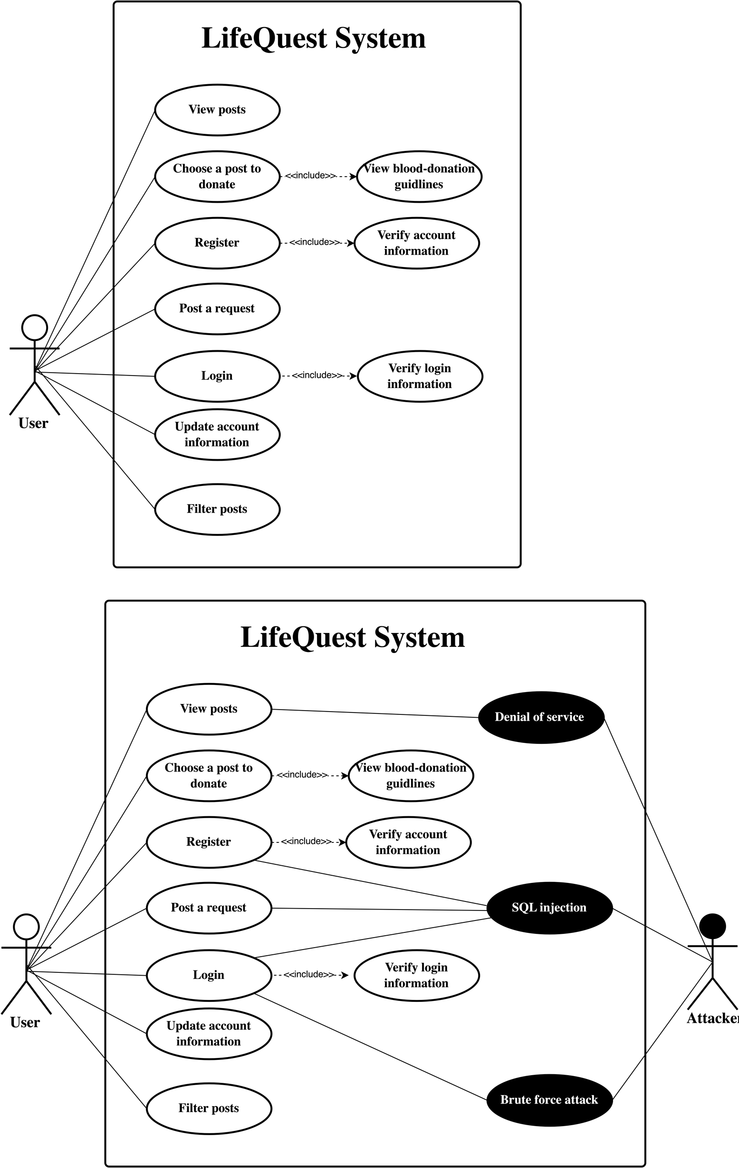

Use Case Description

|  |  |
| --- | --- |
| **LifeQuest system: choosing a post to donate** | |
| Actors | User. |
| Description | User can choose one of the blood donations posts to donate for by contacting the post creator via the creator email address. |
| Data | Posts information and post creators’ emails. |
| Stimulus | The user clicks “Donate” button for specific post. |
| Response | Open user email’s program with post creator email and a page on the website contains a blood donation guideline. |
| Comments | User can choose post request to start contact post creators to donate for them. |

|  |  |
| --- | --- |
| **LifeQuest system: View Posts** | |
| Actors | User |
| Description | Users can view blood request posts based on applied filters. Users can filter results by blood type, location, and/or type of donation (whole blood, platelet, or plasma donation). |
| Data | Blood donation request posts. |
| Stimulus | The user wants to view all the posts, or the user wants to find posts based on specific conditions. |
| Response | View blood donation request posts. |
| Comments | The user can view posts without any conditions, or with a set of conditions “filters”. |

|  |  |
| --- | --- |
| **LifeQuest system: Post a Request** | |
| Actors | user |
| Description | User can fill blood donation request form and post it with all the details on the website. The post will be available for all website users. |
| Data | Blood donation request posts. |
| Stimulus | The user open create post page to create post looking for a blood donor. |
| Response | * The post is saved in the database successfully and appears on the posts page for all users. * If the user didn’t fill in all the required fields in the form, the website will show an error message and ask the user to enter the missing fields. |
| Comments | The user is required to fill in the mandatory fields in order to post a request. |

|  |  |
| --- | --- |
| **LifeQuest system: Register** | |
| Actors | User. |
| Description | User account can be created by clicking “Sign up” button. Then, the user must enter right necessary information to create a new user account. |
| Data | Username, password, email, phone number, blood type, national ID, date of birth. |
| Stimulus | Open the website and wants to be able to log into their account. |
| Response | Create new user account. |
| Comments | The new user account can be created if the user enters all the required information that must be valid. |

|  |  |
| --- | --- |
| **LifeQuest system: view blood donation guidelines** | |
| Actors | User. |
| Description | User can view all blood donation guidelines and information after choosing a blood donation request. |
| Data | The blood donation guidelines. |
| Stimulus | The user clicks “Sure” button. |
| Response | User receives an email with all required information. |
| Comments | User can view all blood donation guidelines before confirming the donation offer. |

|  |  |
| --- | --- |
| **LifeQuest system: Filter posts** | |
| Actors | User. |
| Description | All website users can filter the posts based on the fields they interest in. Users can filter the displayed posts by blood type, blood donation type, and/or the city name. |
| Data | Blood donation request posts. |
| Stimulus | The users want to find blood request posts they can donate to them, e.g., they live in the same city, or they have the same blood type. |
| Response | Redisplay the posts to show only the post's complaints with filters the user selects. |
| Comments | The filter is an optional feature for website users. The user can select all the filters, one filter, or none of the filters. |

|  |  |
| --- | --- |
| **LifeQuest system: Update account information** | |
| Actors | User. |
| Description | The user can update the account information. |
| Data | User’s account information. |
| Stimulus | After the user logged in, he can update the account information by clicking the update button. |
| Response | Update the user's account information and show a confirmation message |
| Comments | There is no restriction on what the user can update, except for the national id. |

|  |  |
| --- | --- |
| **LifeQuest system: Login** | |
| Actors | User. |
| Description | The user account can be accessed by entering the correct username and password after registration. Each time the user logs in, a new session is established. |
| Data | Username, password. |
| Stimulus | User command issued by system authentication. |
| Response | Accessing the website successfully. |
| Comments | The user must have permission (an account) to access to login to the website. |

Misuse case diagram

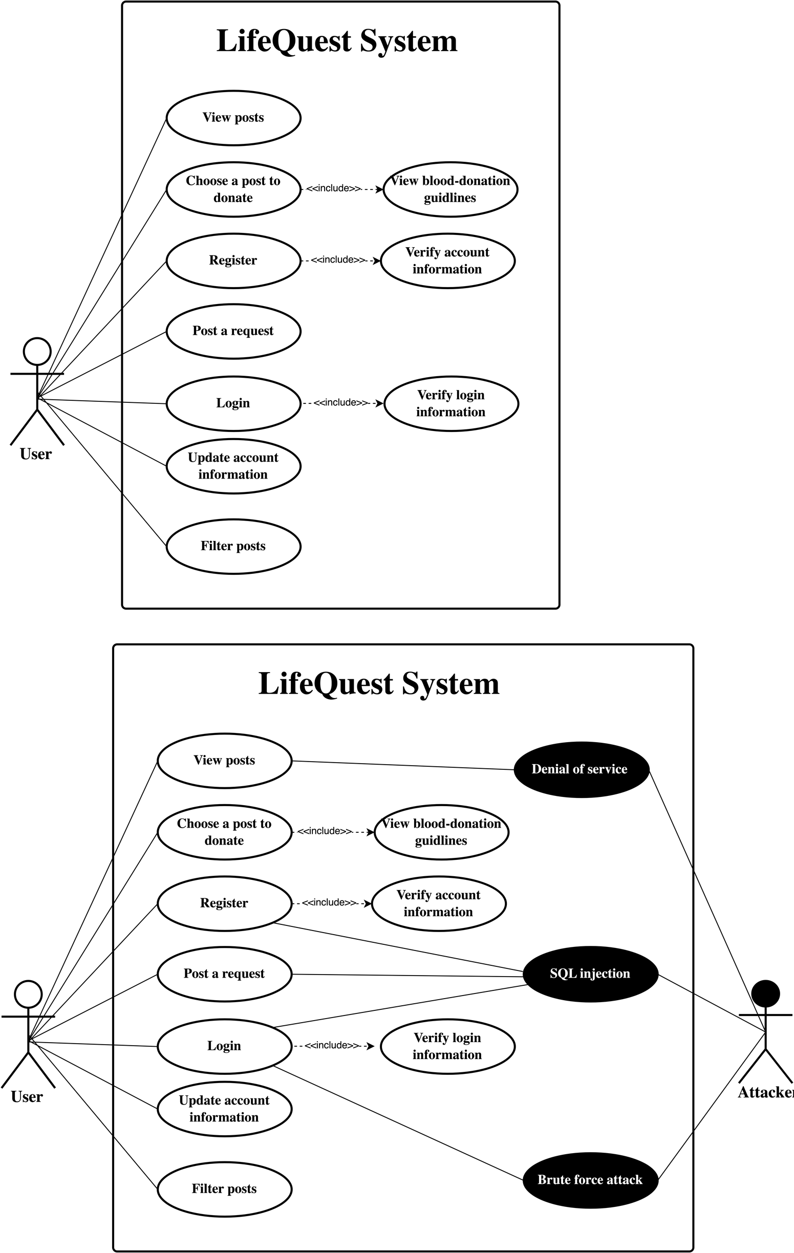

Misuse case Description

|  |  |
| --- | --- |
| **LifeQuest system: Denial of Service Attack (Misuse case)** | |
| Actors | User, Attacker. |
| Description | Impact system availability by making the system services inaccessible to its intended users. |
| Data (assets) | Blood donation requests. |
| Attacks | Overwhelming or flooding the system servers with requests (traffic) until normal traffic is unable to be processed. [2] |
| Mitigations | Identifying and banning unauthorized traffic at the routing level, managing and evaluating the services' bandwidth. |
| Requirements | * Attack Detection * Allowing and Denying Specific IPs. * Rate Limiting * Upstream Filtering and DDS. * Programming for Scale |

|  |  |
| --- | --- |
| **LifeQuest system: Brute Force Attack (Misuse case)** | |
| Actors | User, Attacker |
| Description | The attacker guesses login info to gain unauthorized access to the web page |
| Data (assets) | Login information |
| Attacks | Use excessive automated forceful attempts by working through all possible combinations of usernames and passwords hoping to guess correctly [1] |
| Mitigations | Ensure that the user is using an advanced strong username and password, certificate-based client-server communication must be used |
| Requirements | * All usernames and passwords must be checked for strength * All communications between the client and the server must use the SSL. The https protocol uses certificate-based authentication and encryption |

|  |  |
| --- | --- |
| **LifeQuest system: SQL injection (Misuse case)** | |
| Actors | User, Attacker. |
| Description | SQL injection is exploited to read sensitive data, modify database data (insert, update, or delete), or execute some operations on the database. [3] |
| Data (assets) | Login information, account information. |
| Attacks | Insertion or injection of SQL query via the input data from the attacker to the website. |
| Mitigations | Check the validity of all user inputs to the system before process it and store it in the database. |
| Requirements | * Verify user input based on given rules * Set a customized criteria to be checked for each input field. * Provide a dropdown menu whenever it is feasible to reduce user input as possible. |

Design risk assessment

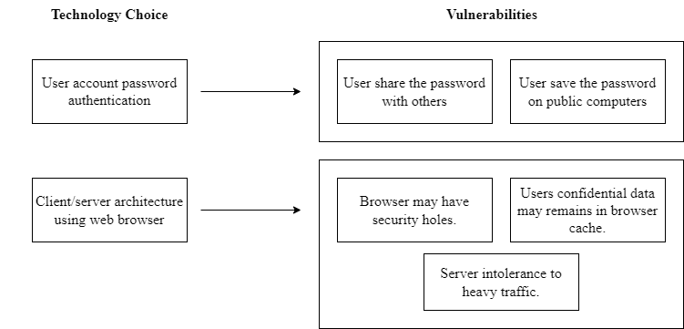

Design decisions

Dependable programming guidelines

|  |  |  |
| --- | --- | --- |
| Guidelines | Applicable? | How? |
| Limit the visibility of information in a program | Yes | Storing user information in a private sql tables and using private variables in the system whenever is possible. |
| Check all inputs for validity | Yes | Validate all input entered by the user is valid (email address must contain @), national ID must contain only numbers, password must contain at least 8 characters and 1 uppercase letter and 1 lowercase letter, and phone number should be at most 10 characters. Also, validate all the input fields for creating new post. |
| Provide a handler for all exceptions | Yes | Handler exceptions for all methods that handle all exceptions are provided. |
| Minimize the use of error-prone constructs | Yes | Processing inputs after ensuring its type and validity. Avoid using more than one name to refer to state variable. |
| Provide restart capabilities | Yes | Our website is providing restart capabilities by allowing the user to just re-enter the wrong input. |
| Check array bounds | No | - |
| Include timeouts when calling external components | No | - |
| Name all constants that represent real-world values | No | - |

Security guidelines

|  |  |  |
| --- | --- | --- |
| Security Guidelines | Applicable? | What design used? |
| Base security decisions on an explicit security policy | No |  |
| Avoid a single point of failure | Yes | Ensure that when several procedures are carried out, the system may fail. As an illustration, if an attacker attempts to get into the system and enters the correct email address but the incorrect password, a warning stating "Your email address or password incorrect" will appear, making it difficult for the attacker to access the user login information. |
| Fail securely | Yes | We retain user information in distinct places from other information. |
| Balance security and usability | Yes | While concentrating on building a secure website that guards its assets against failure situations, we also provide a simple navigation process and a friendly user experience to boost usability. |
| Log user actions | No |  |
| Use redundancy and diversity to reduce risk | Yes | We won't lose our work if the attacker or any other external resource damages our project because we are using a different server from our database to store our project files. |
| Specify the format of all system inputs | Yes | To prevent issues from being caused by unexpected inputs, all system input formats in forms are known, specified as being within range, and compared with a potential pattern. An email address should, for instance, begin with "example.com." |
| Compartmentalize your assets | Yes | We keep our assets in disparate places “database”, so when the system displays information, just the user-required data is shown. |
| Design for deployment | No |  |
| Design for recoverability | No |  |

Security Testing

|  |  |  |  |  |
| --- | --- | --- | --- | --- |
| Security checklist | Input | Expected output | Actual output | Pass/fail |
| Create new user account with all correct inputs. | Username, password, email, national ID, phone number, birthday, blood type. | The page contains a welcoming and successful message. | A page contains a welcoming and successful message. | pass |
| Create new user account with some missing inputs (not entering the username) | Username, password, email, national ID, phone number, birthday, blood type. | Account will not be created, and a “Please fill out the field” message will display | A “Please fill out the field” message is displayed. | pass |
| Create new user account with some invalid inputs (unrequested format of password) | Username, password, email, national ID, phone number, birthday, blood type. | Account will not be created, and a “Please match the request format” message will display | A “Please match the request format” message is displayed. | pass |
| Log in into the system (user account) with all correct login information | Username, password | The user will log his account, and the system will display the home page. | The system displays the home page. | pass |
| Log in into the system (user account) with invalid login information (invalid username) | Username, password | The user cannot access their account, and the system will display the login page again. | The system displays the login page again. | pass |
| Accessing account page while user doesn’t authorize themselves | No inputs | Redirect the user to the login page to be authorized. | The system redirects the user to the login page. | pass |
| Accessing create post page while user doesn’t authorize themselves | No inputs | User can not access it and the website ask to login or sign up first to access it. | The system shows a message that aske the user to login or sign up first. | pass |

Database Design ER model

Since we have a database in the LifeQuest system, we used the Entity Relationship Diagram to sketch out the design of a database and show the relationships of entity sets stored in a database. The figure below shows the ER diagram for the LifeQuest system.

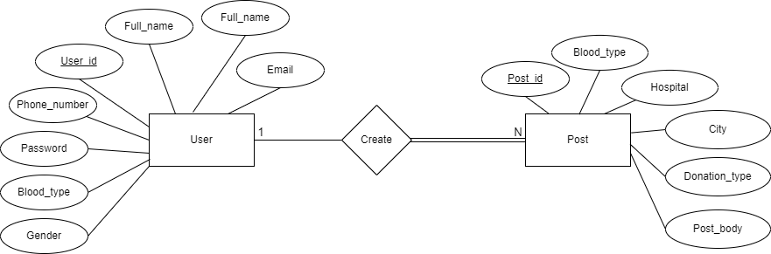

High-level Prototype

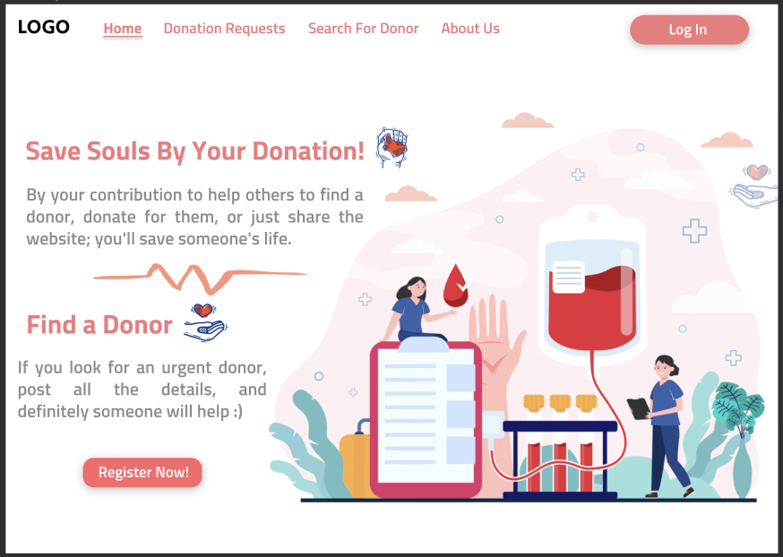

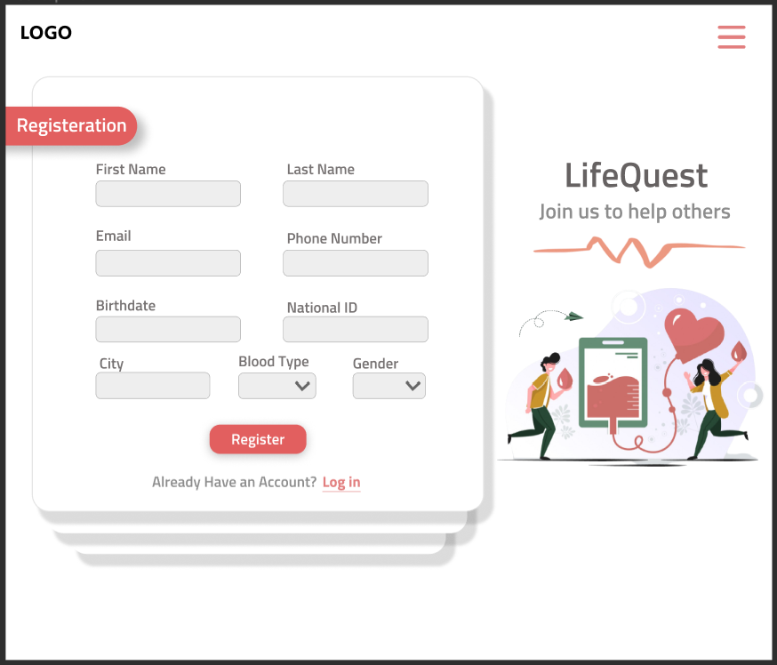

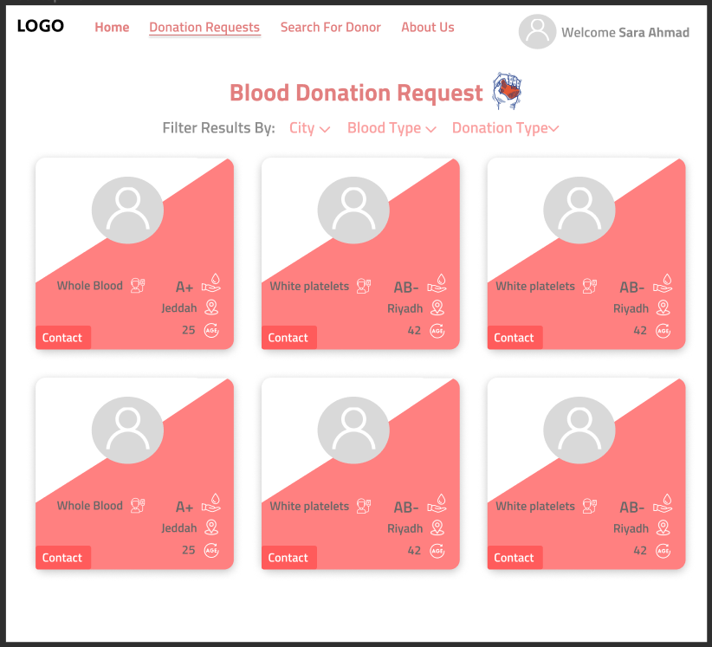

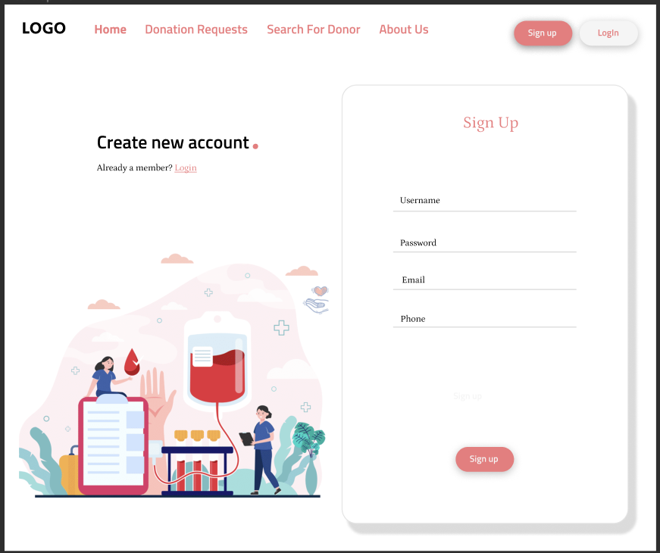

Graphical User Interface

Sign Up Page

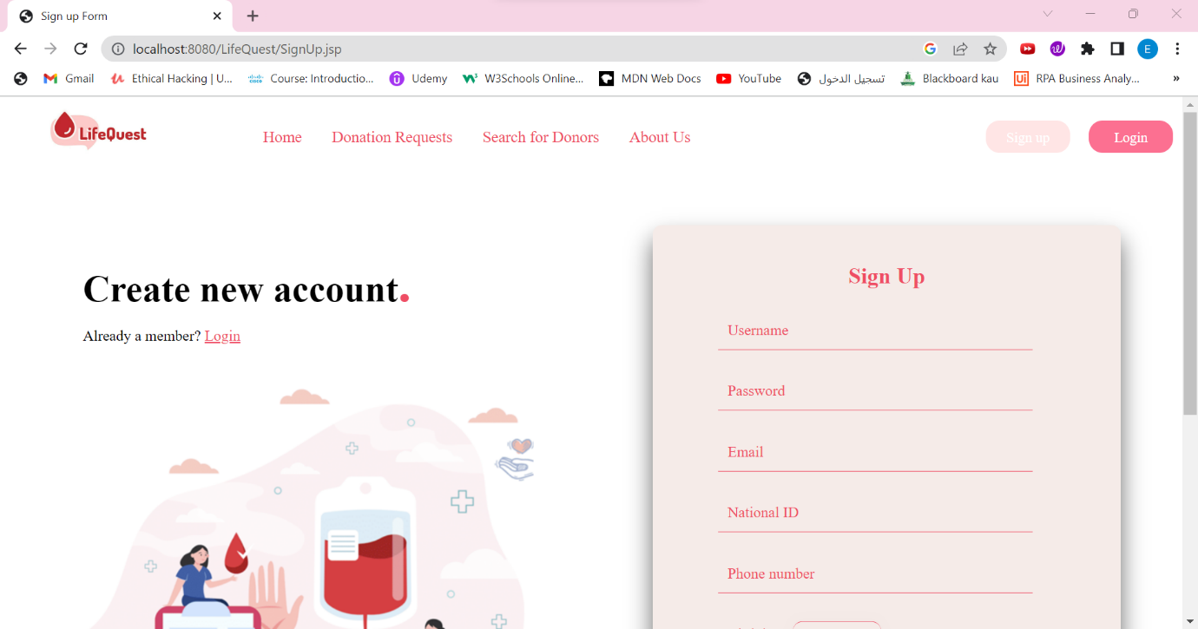

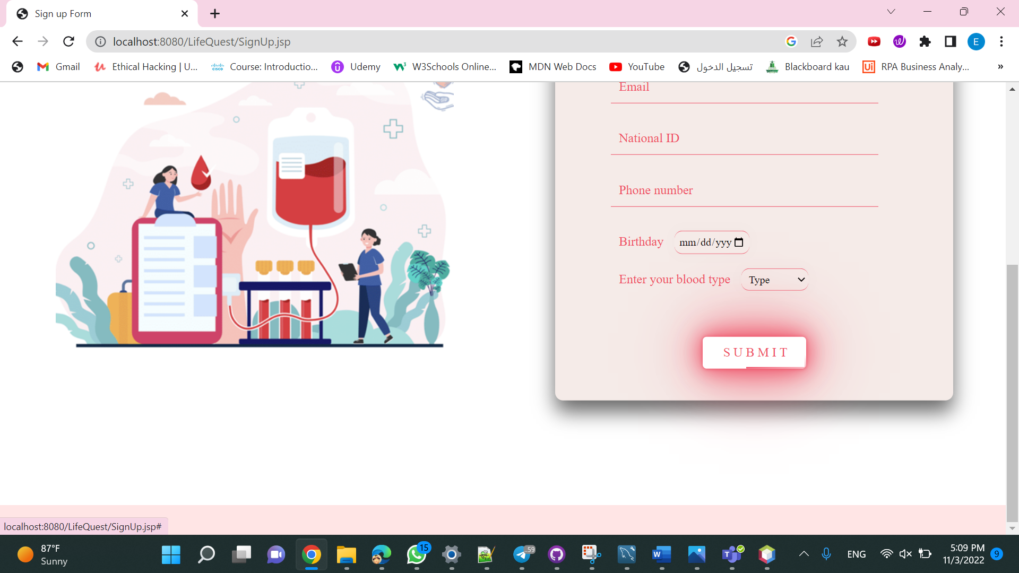

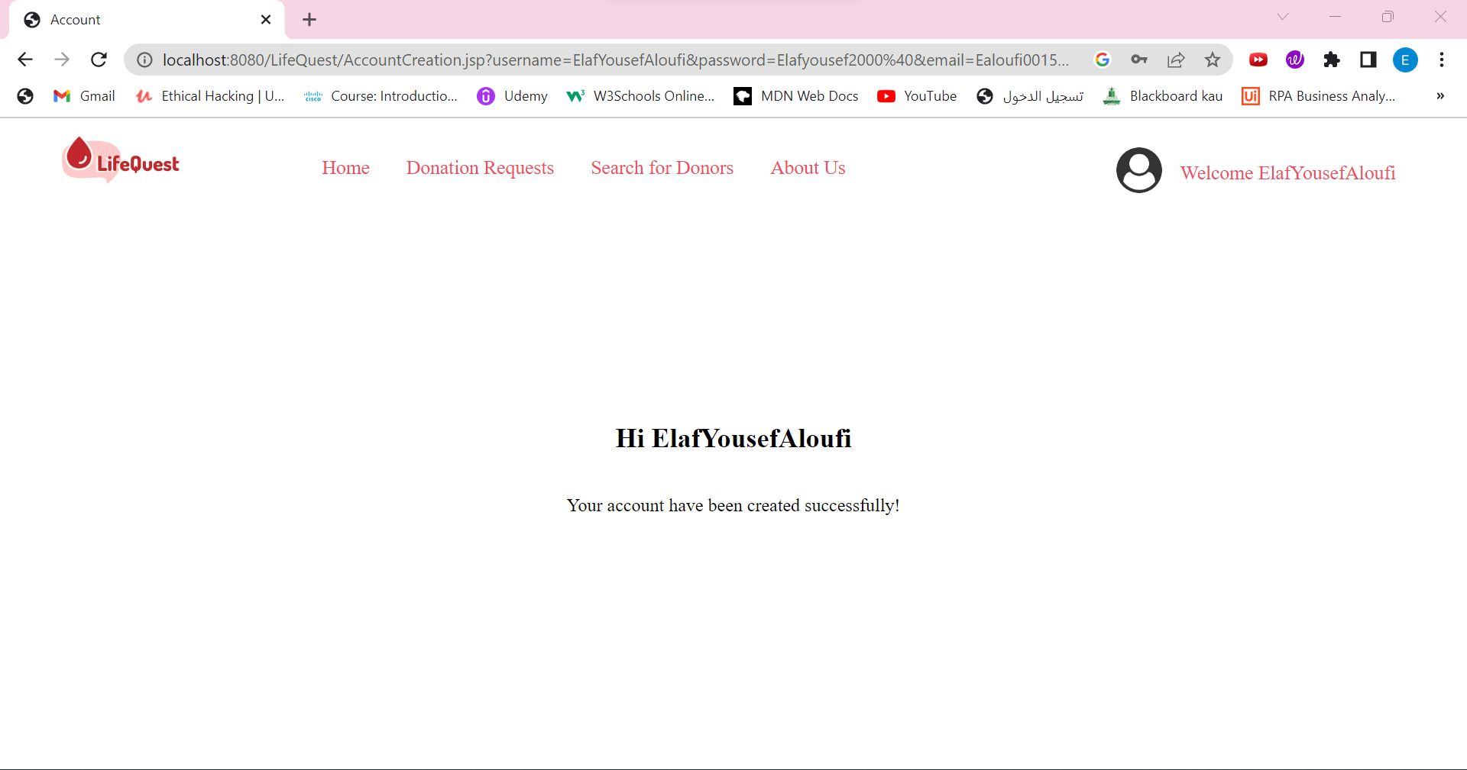

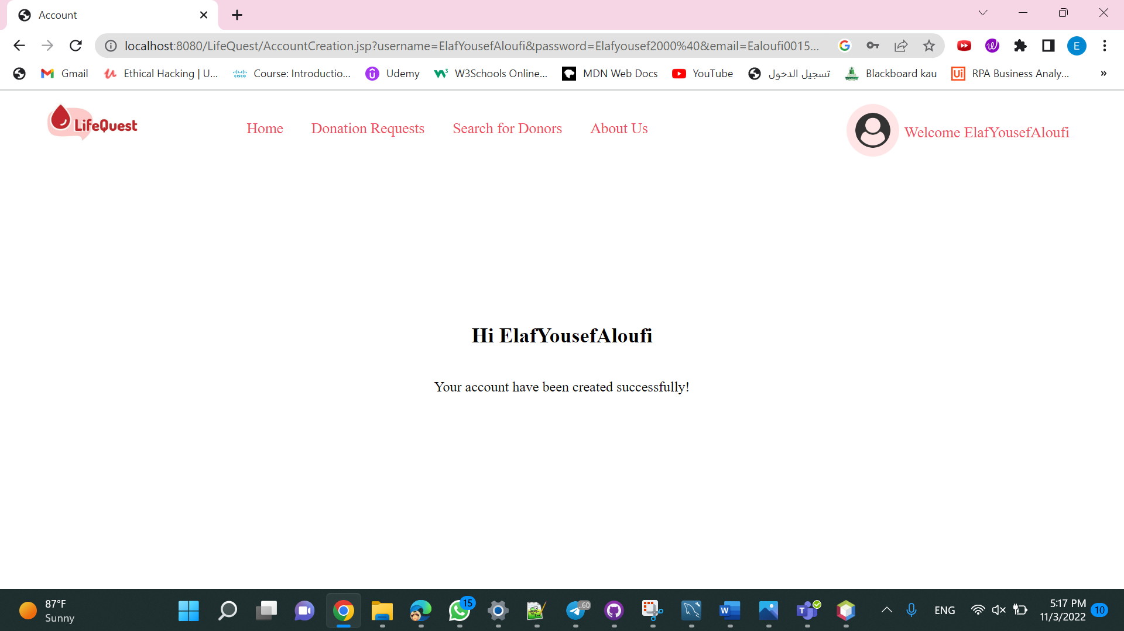

Login Page

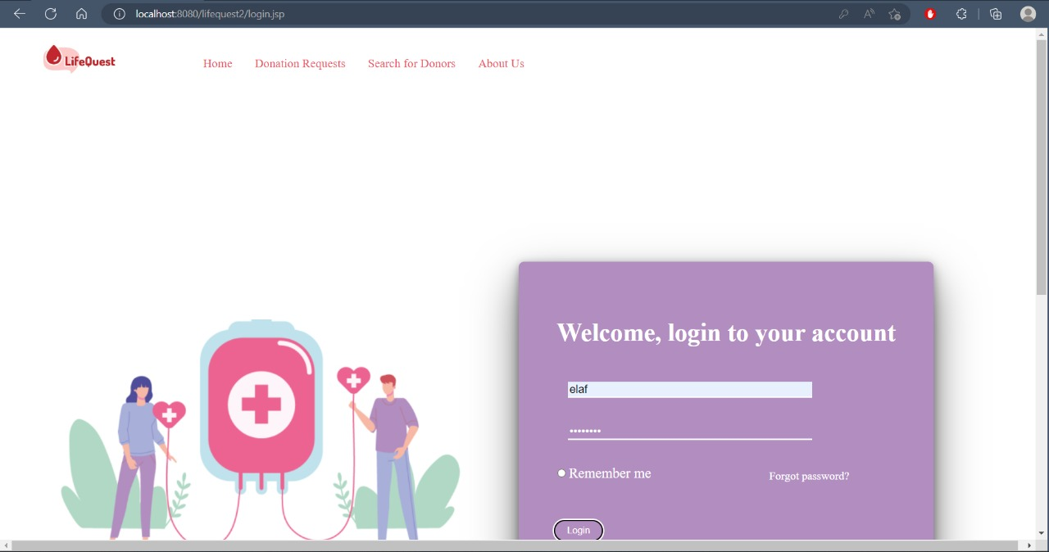

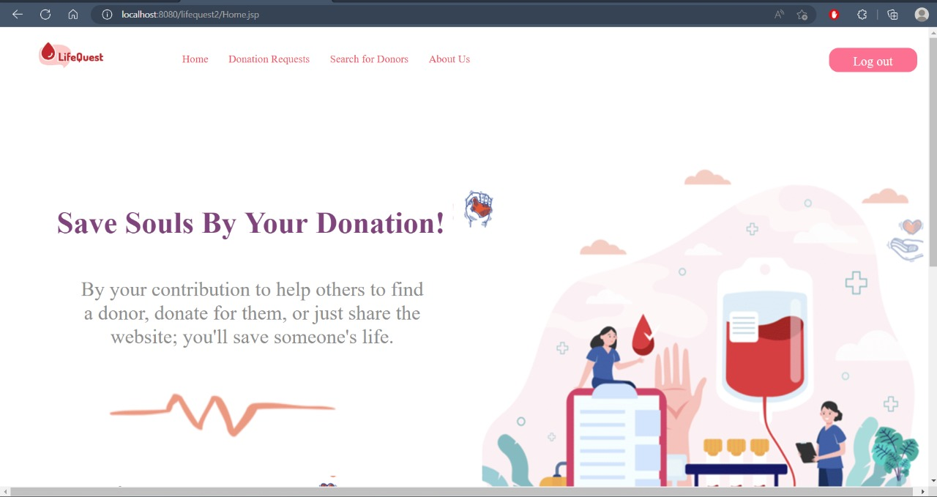

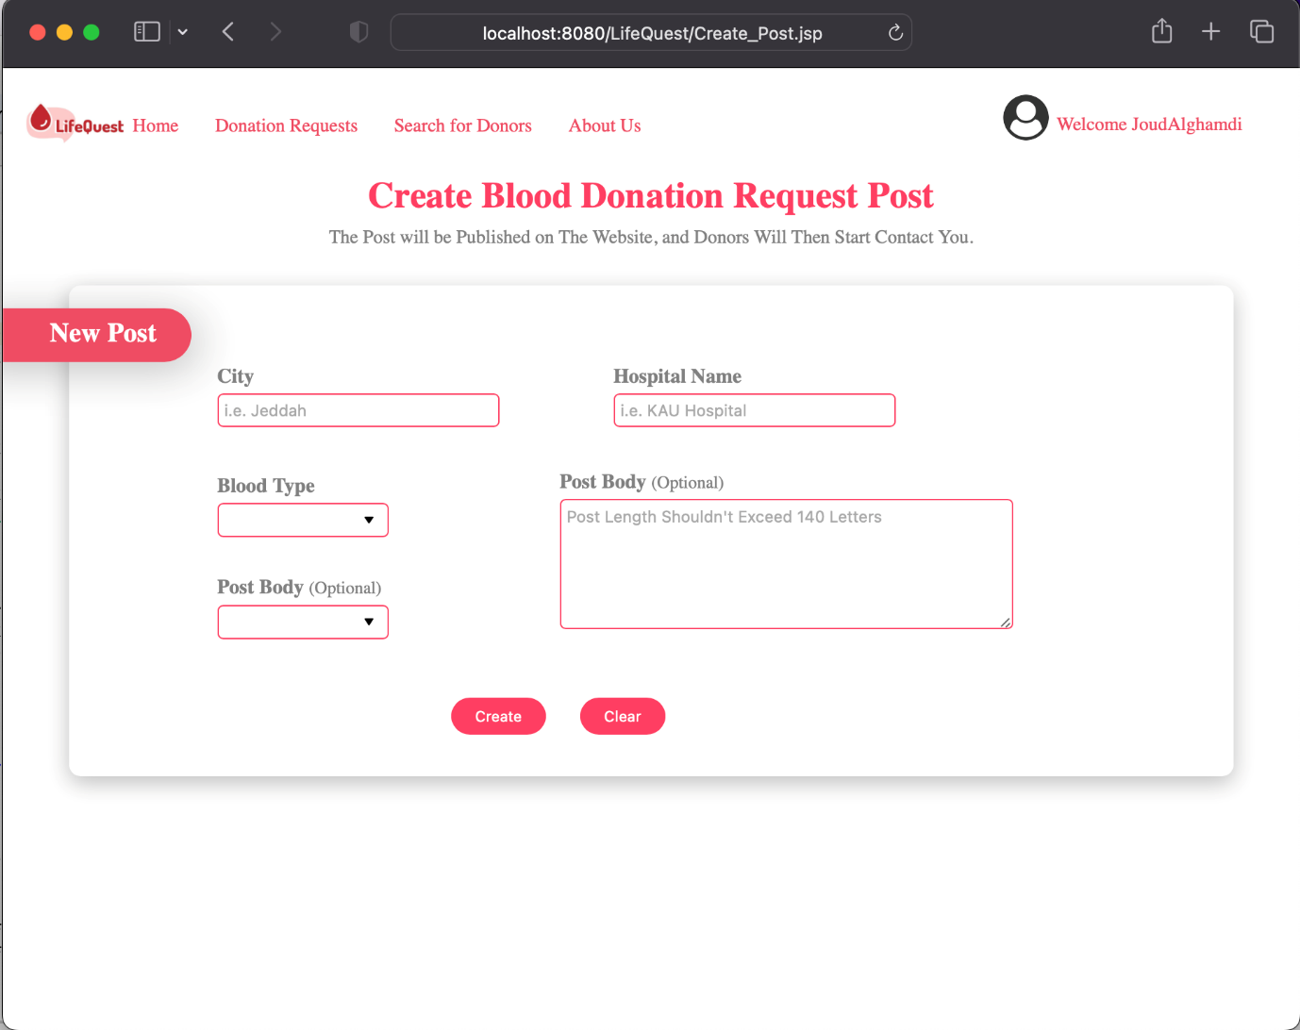Add Post Page

View Posts Page

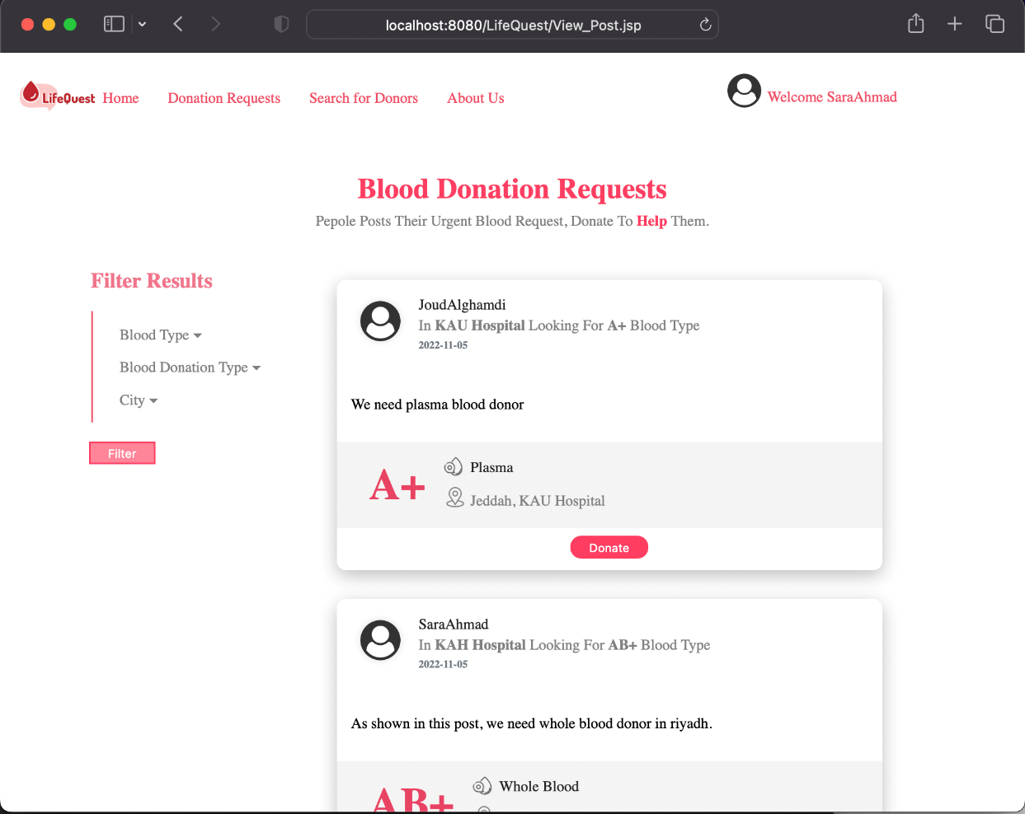

Instruction Page

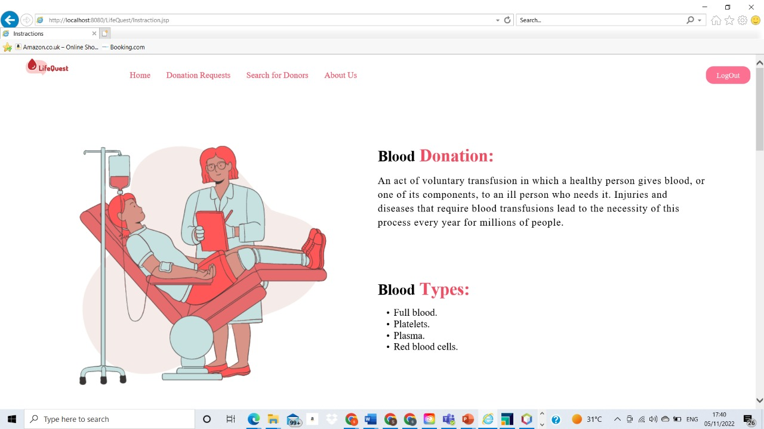

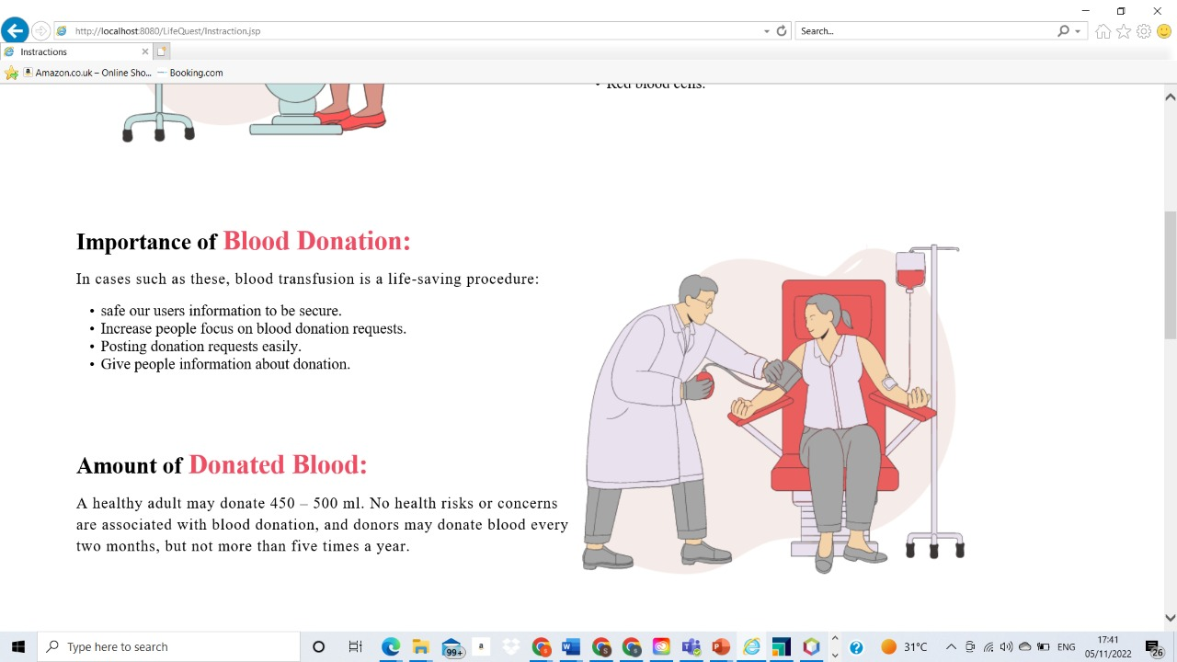

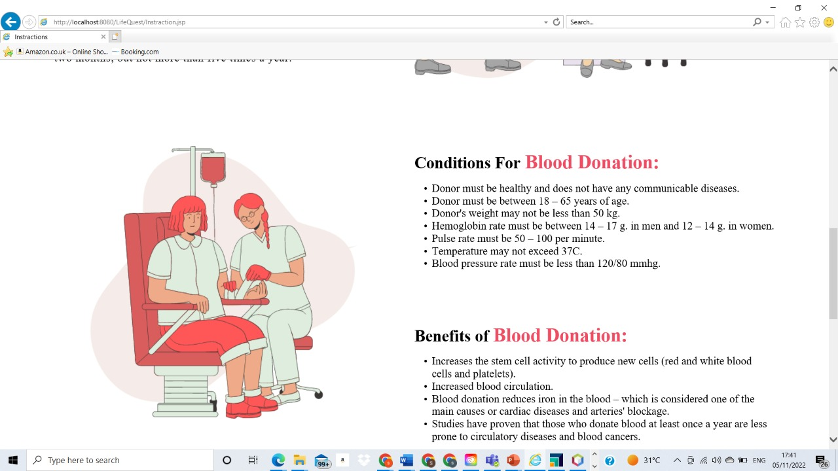

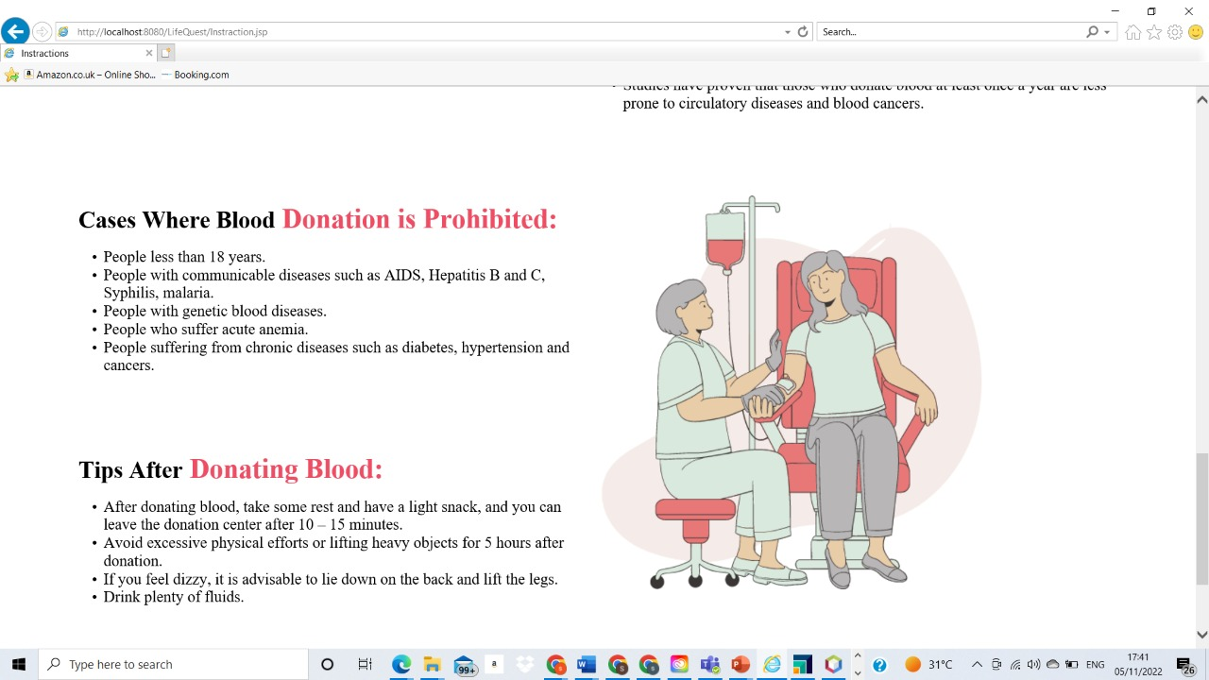

About Us Page

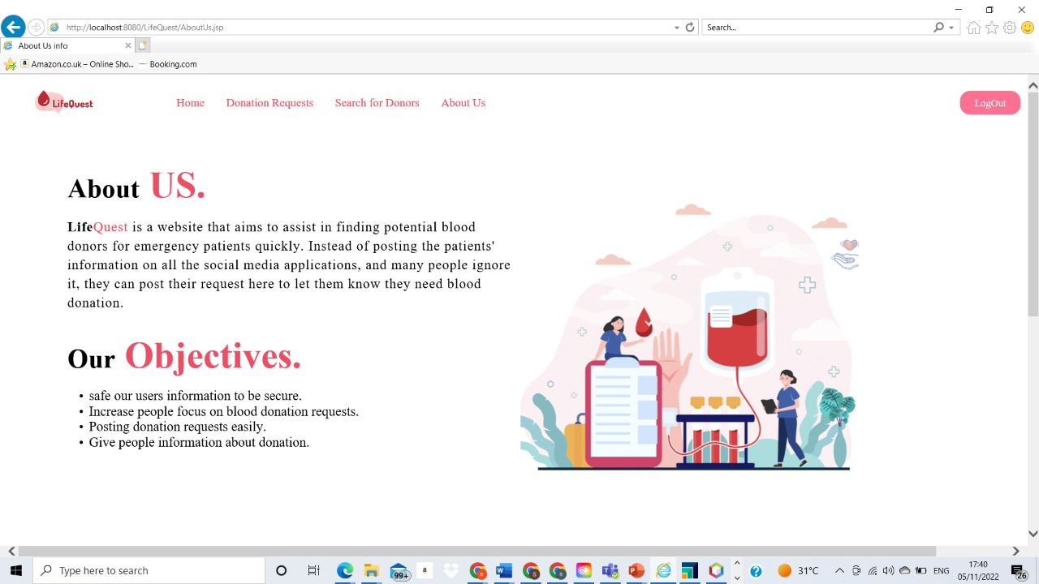

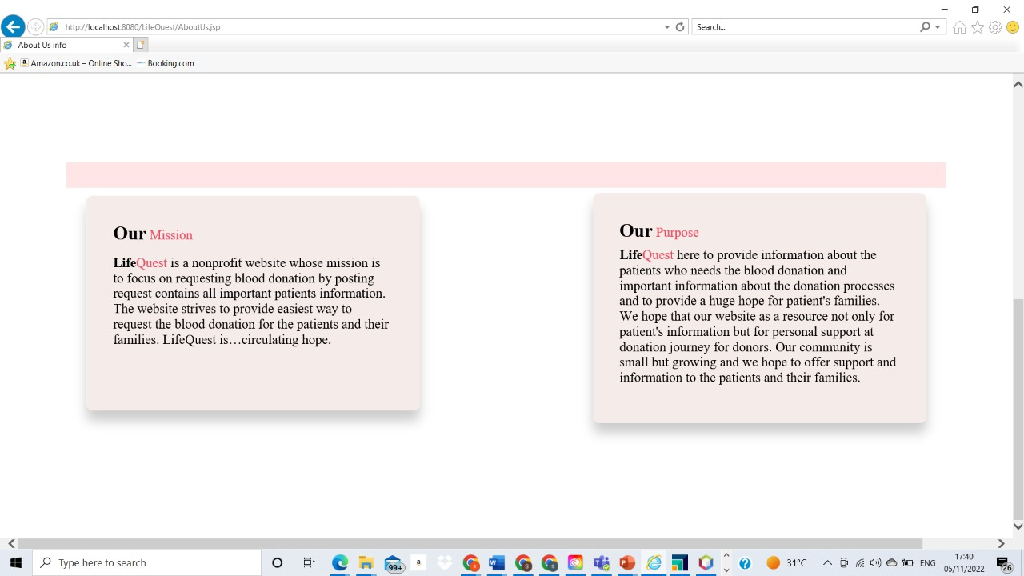

Testing

Sign Up

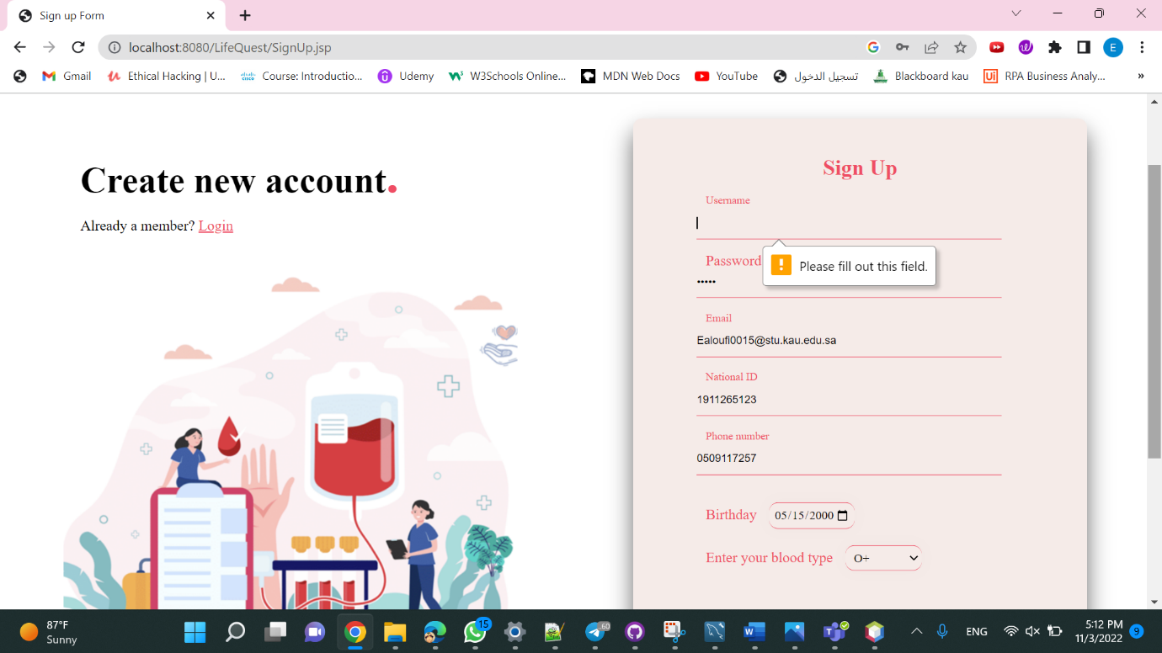

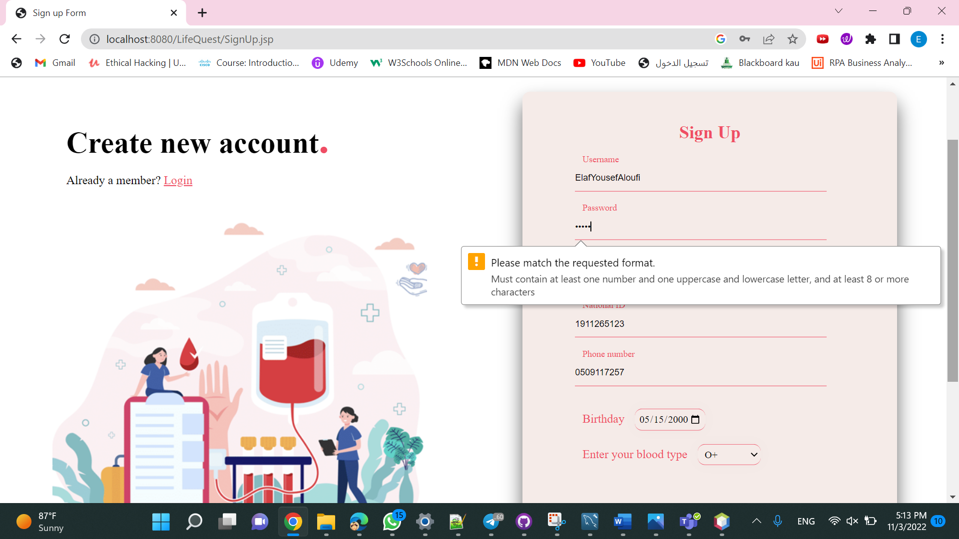

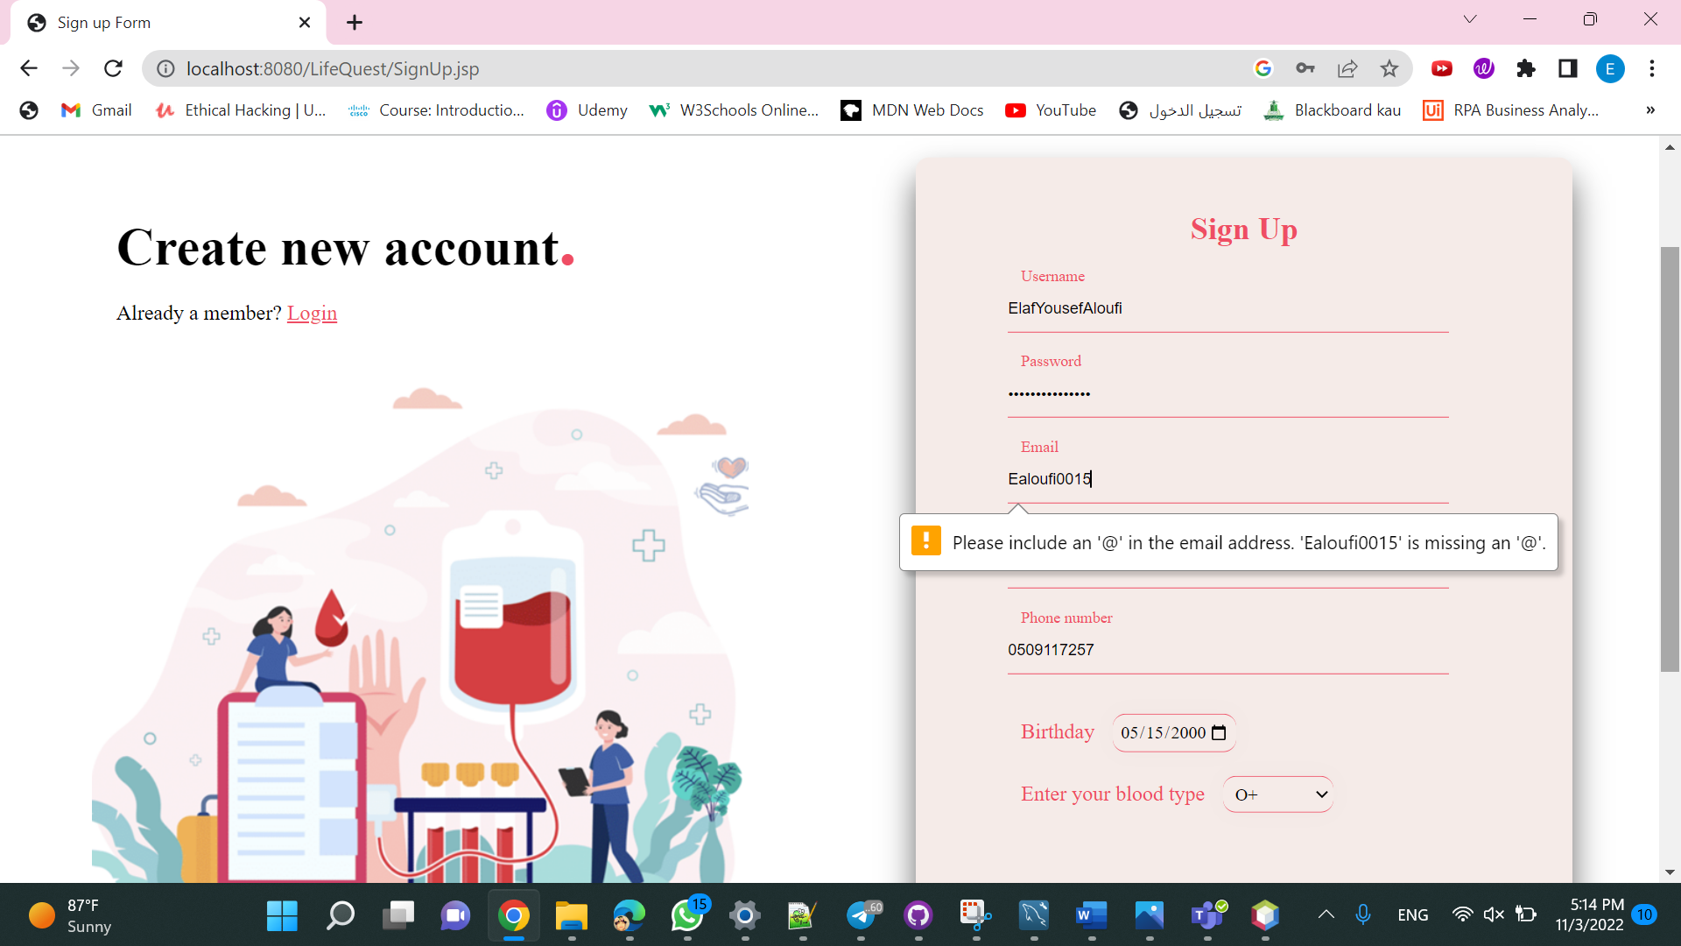

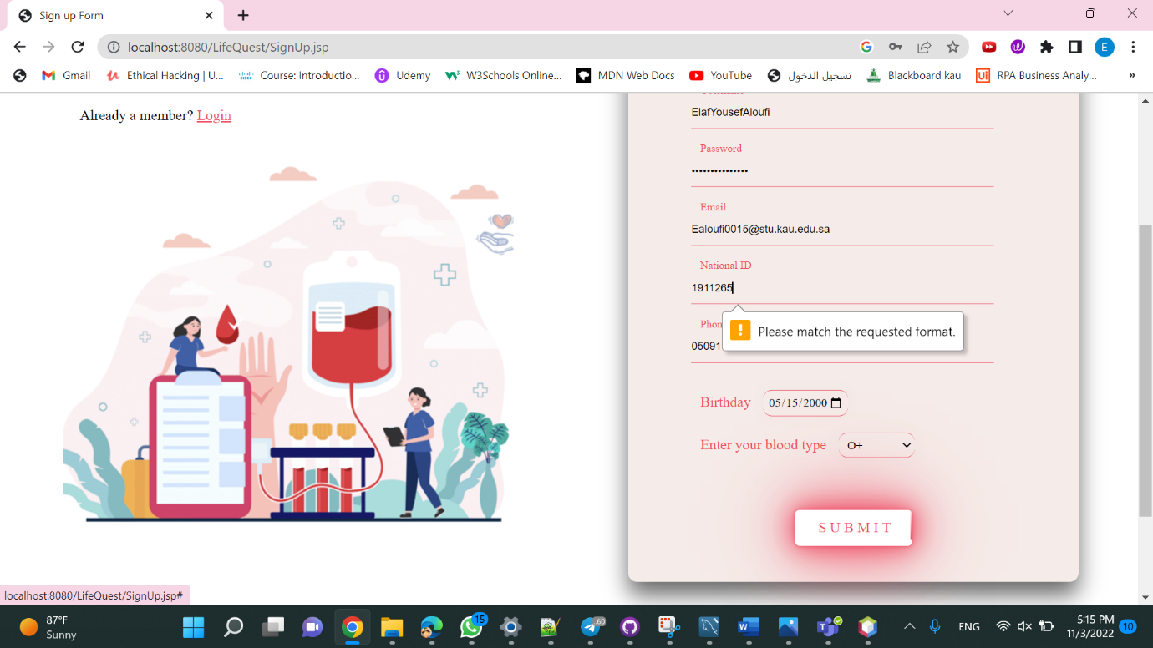

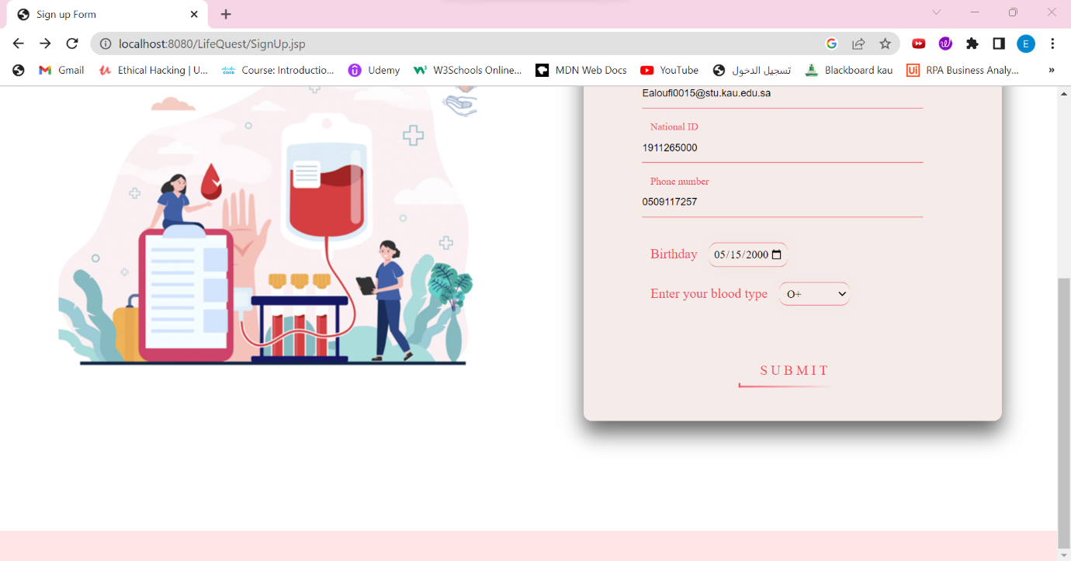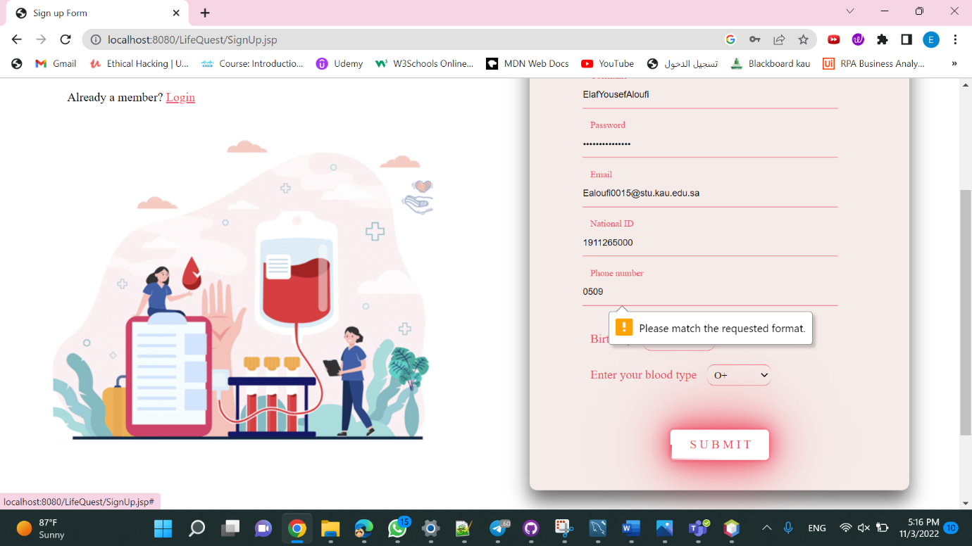

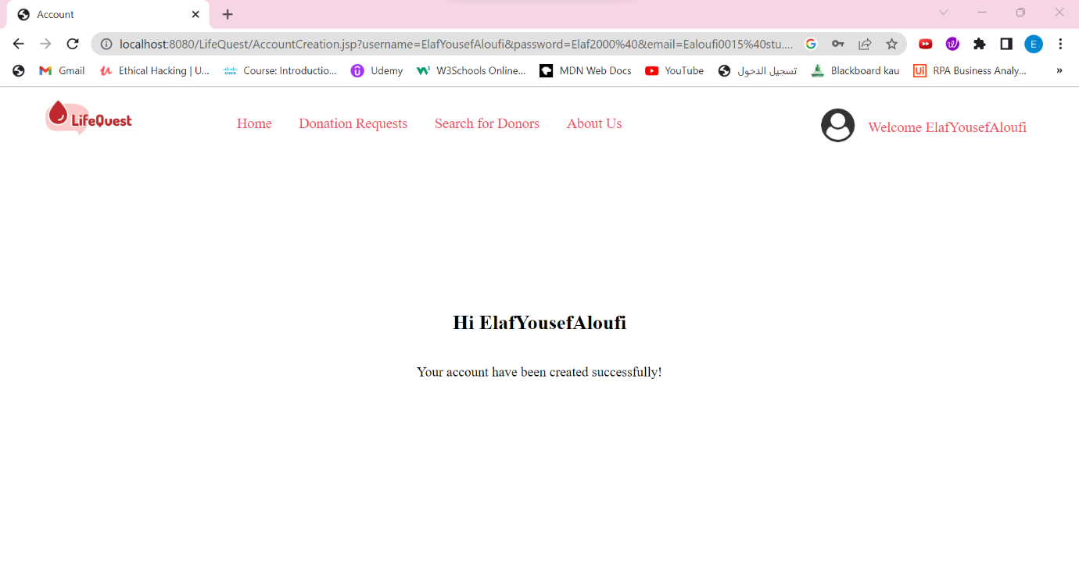

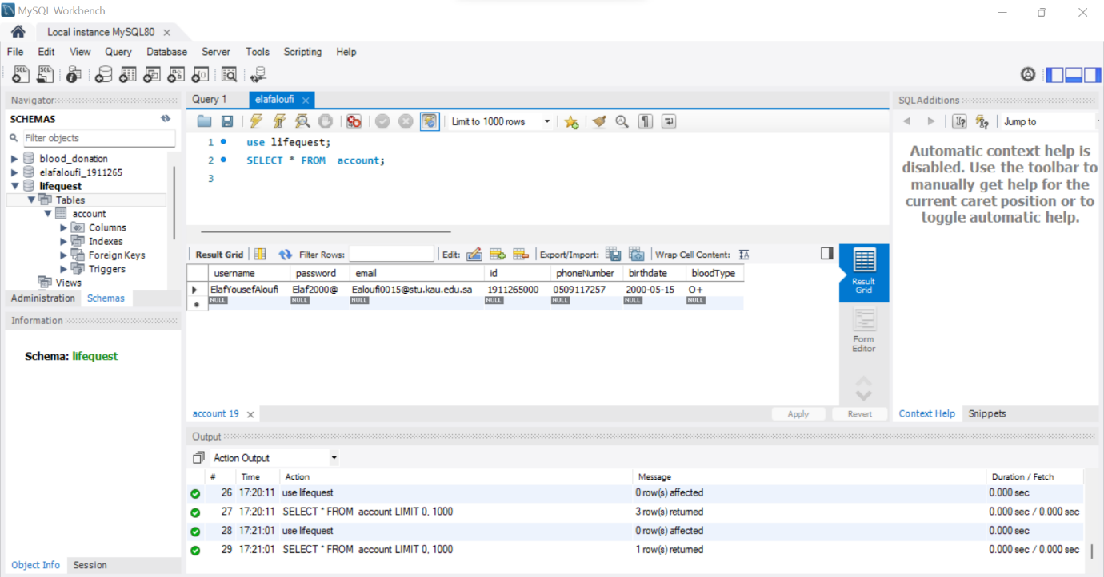

Login



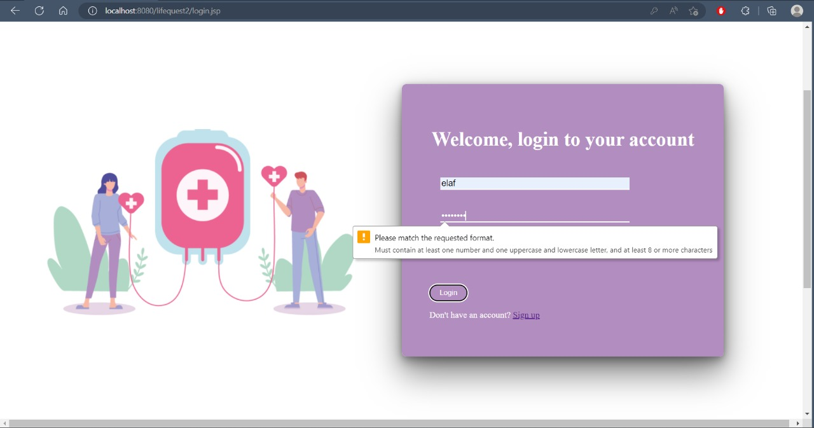



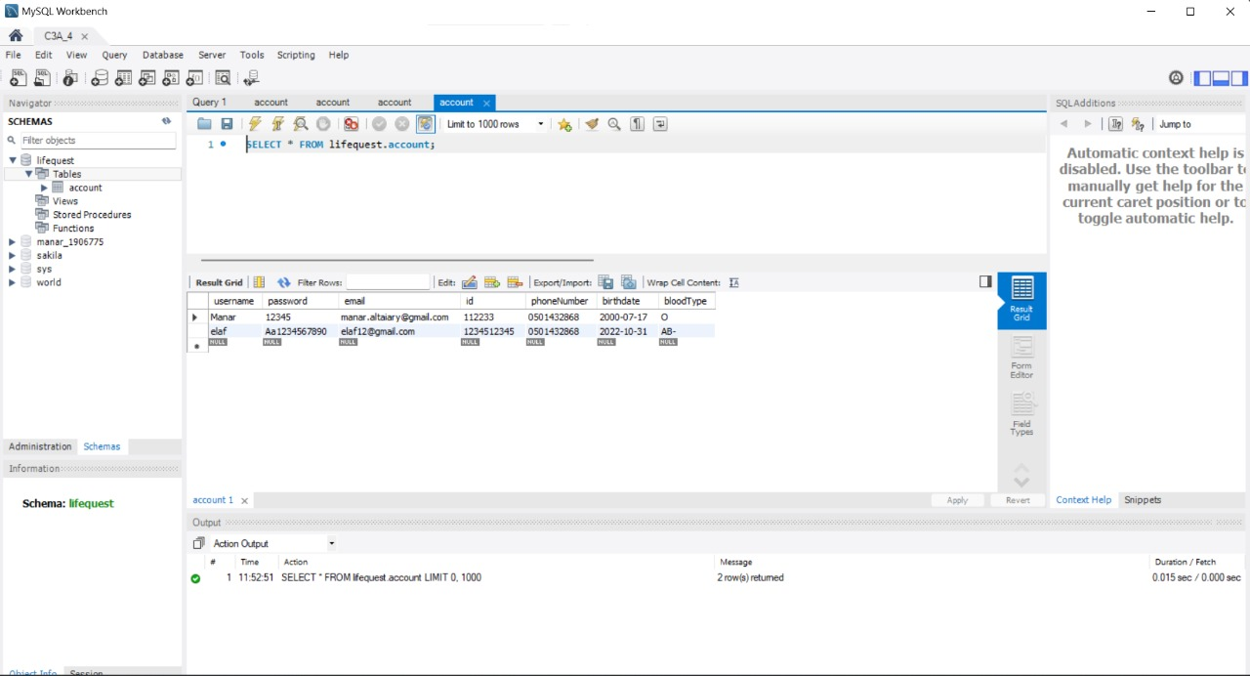

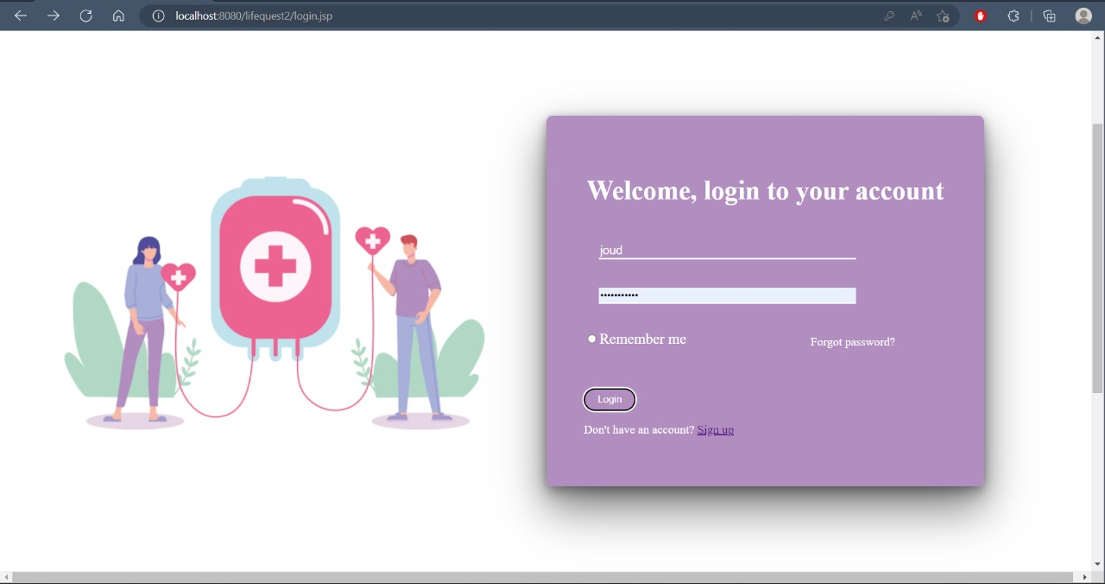

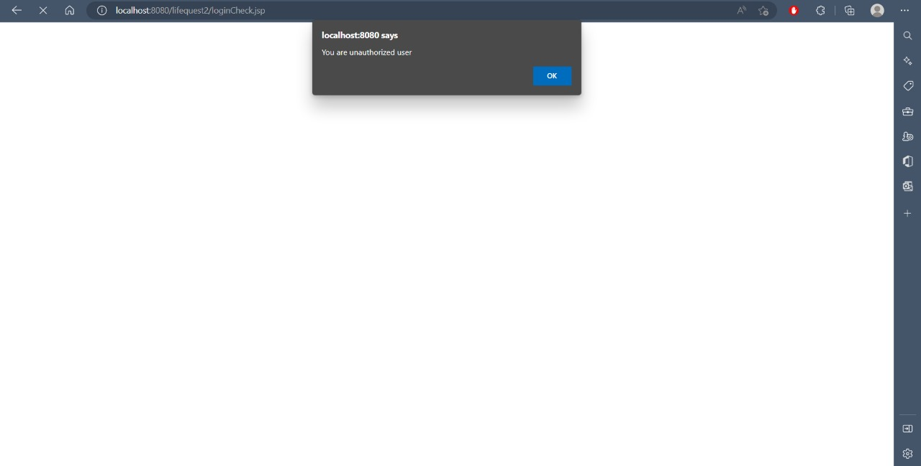

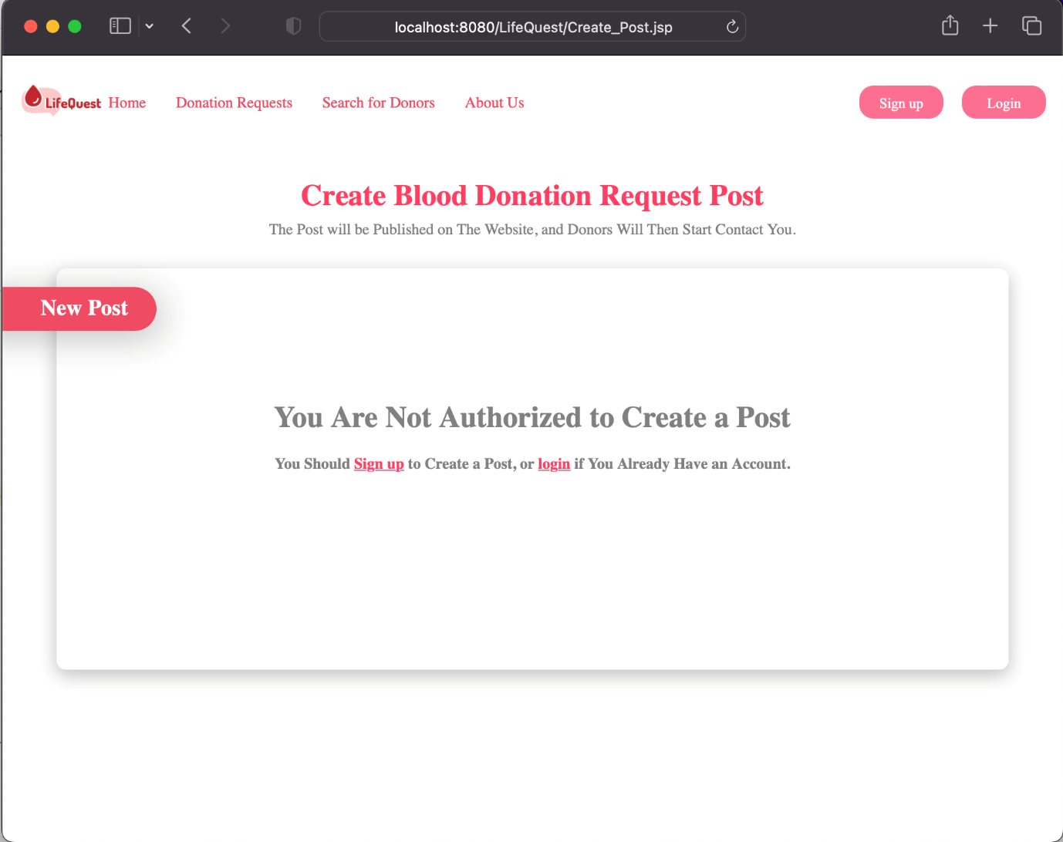 Add Post

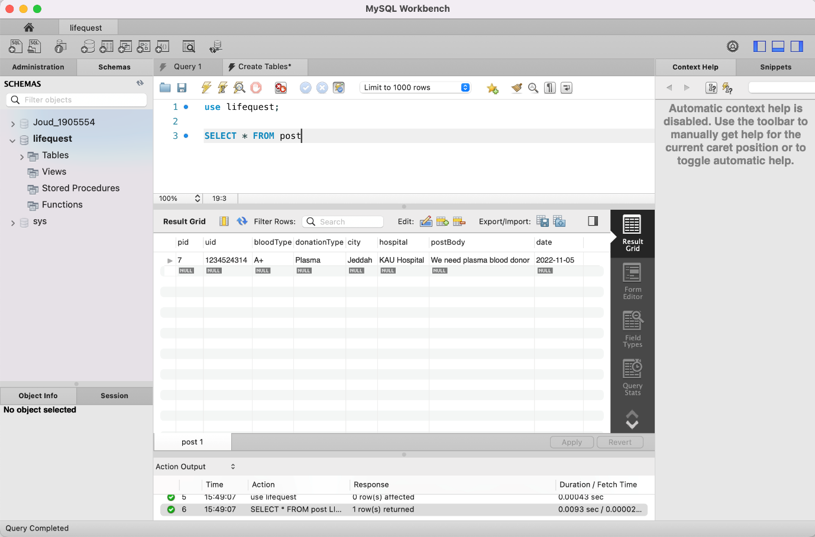

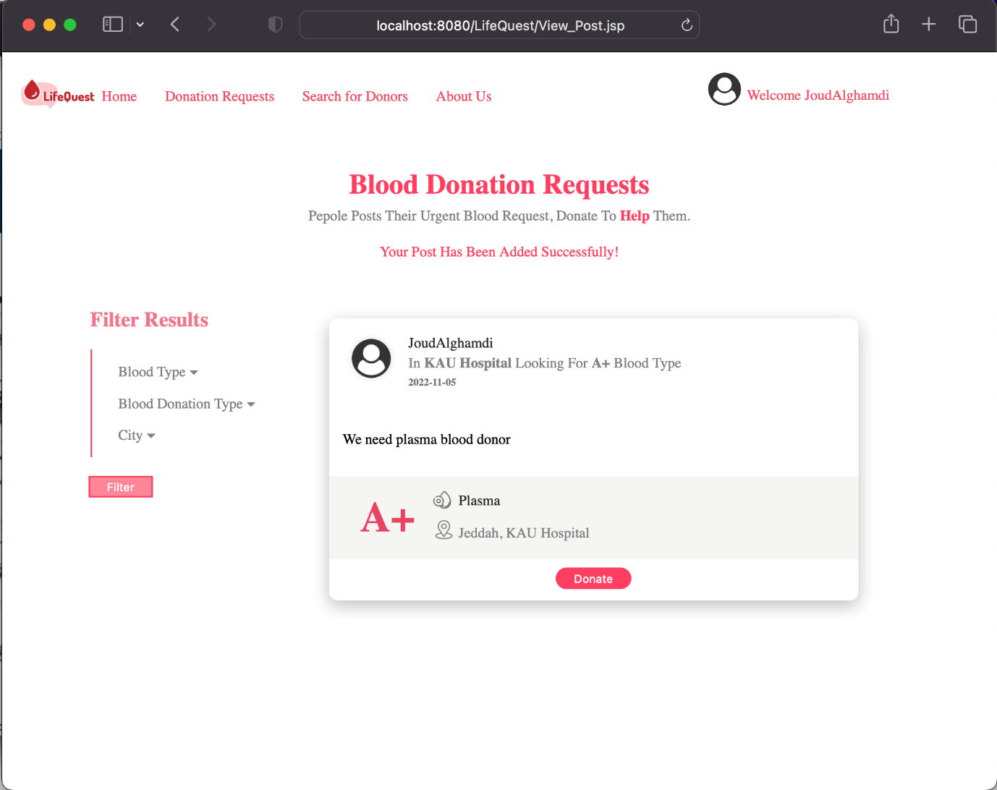

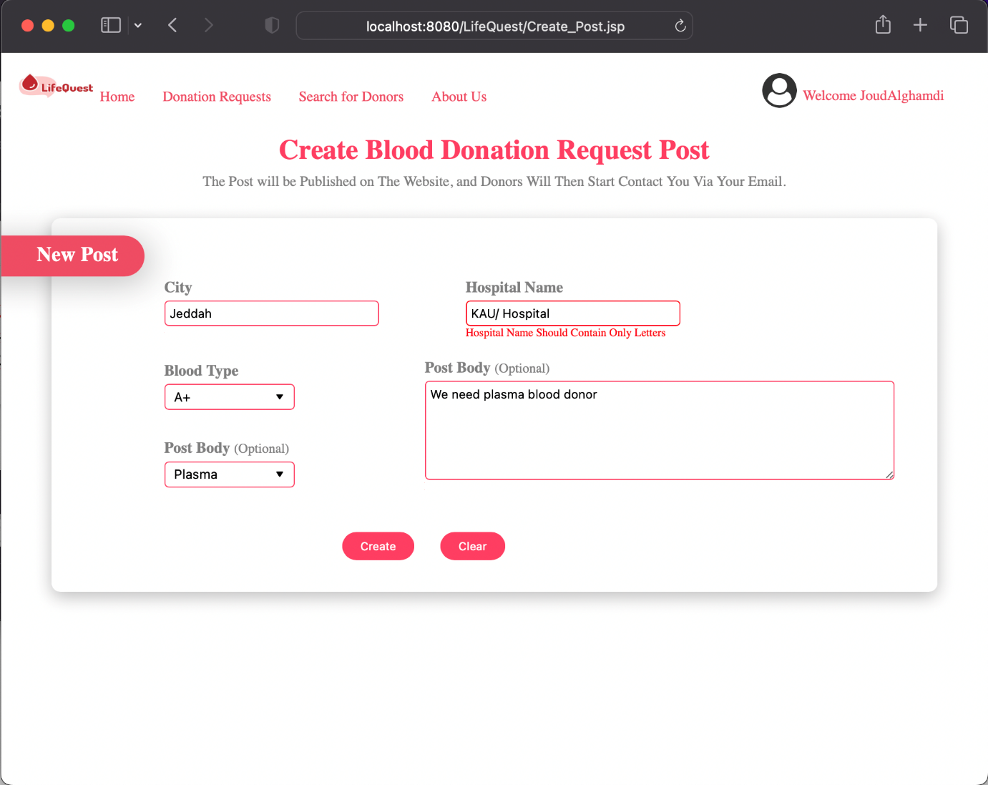

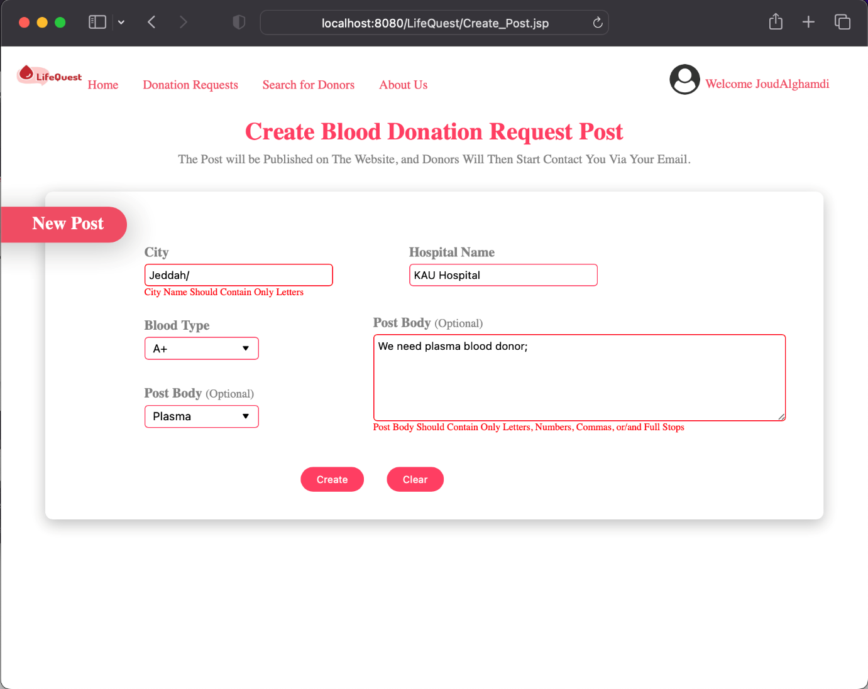

View Post

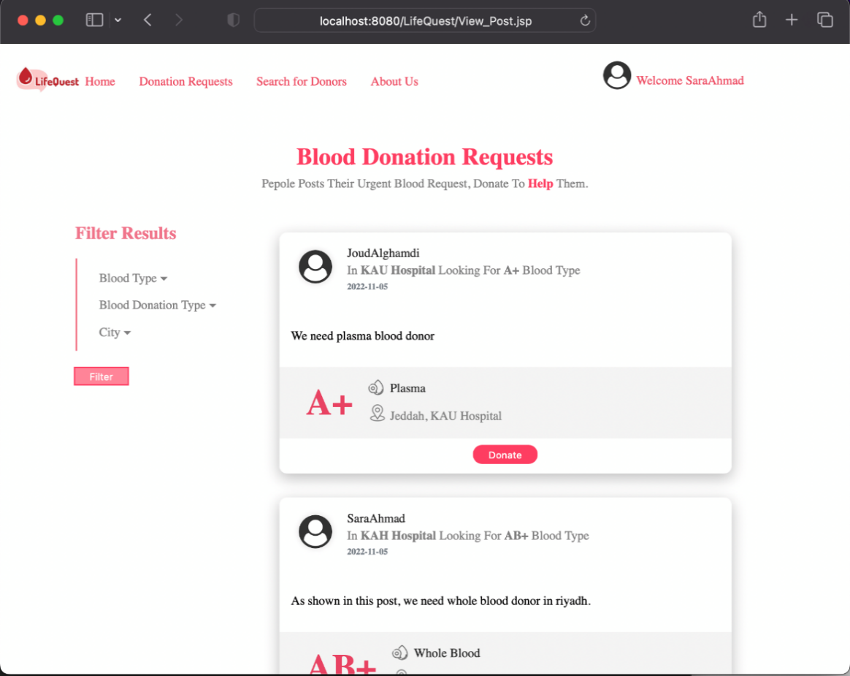

View Post - Donate

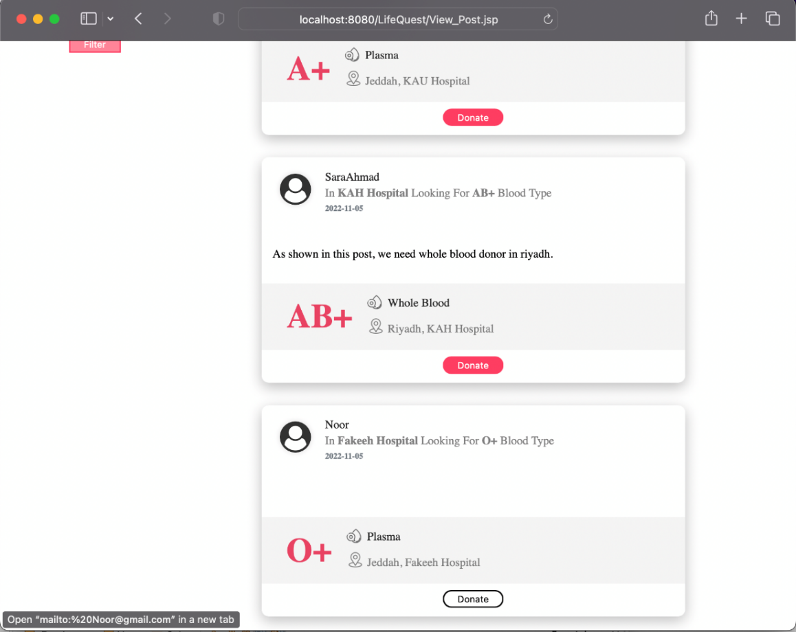

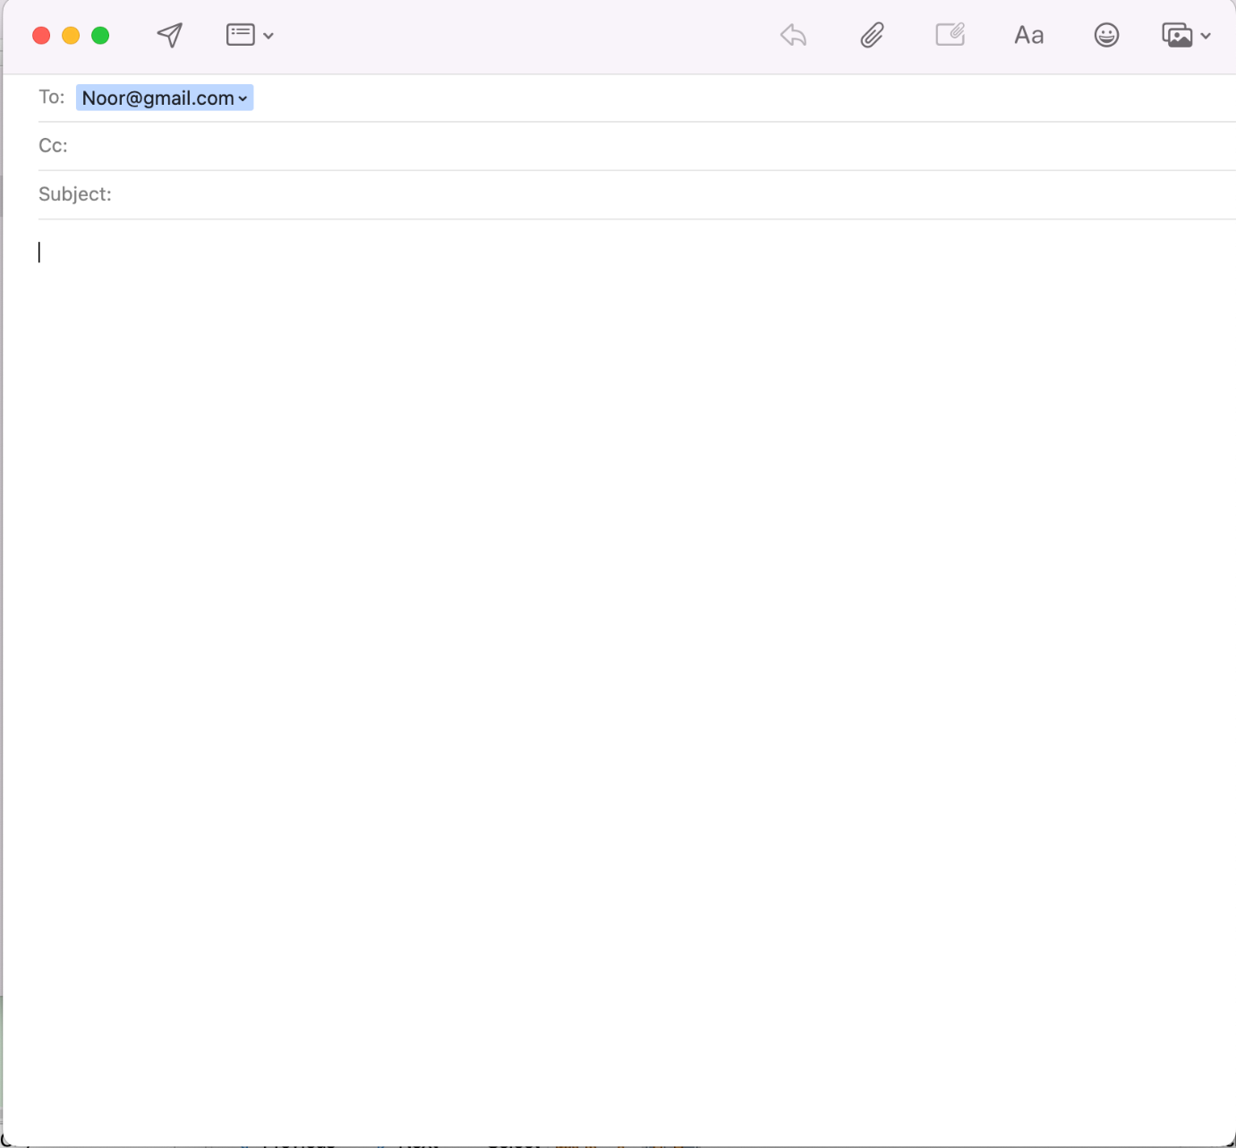

View Post – Filter Posts

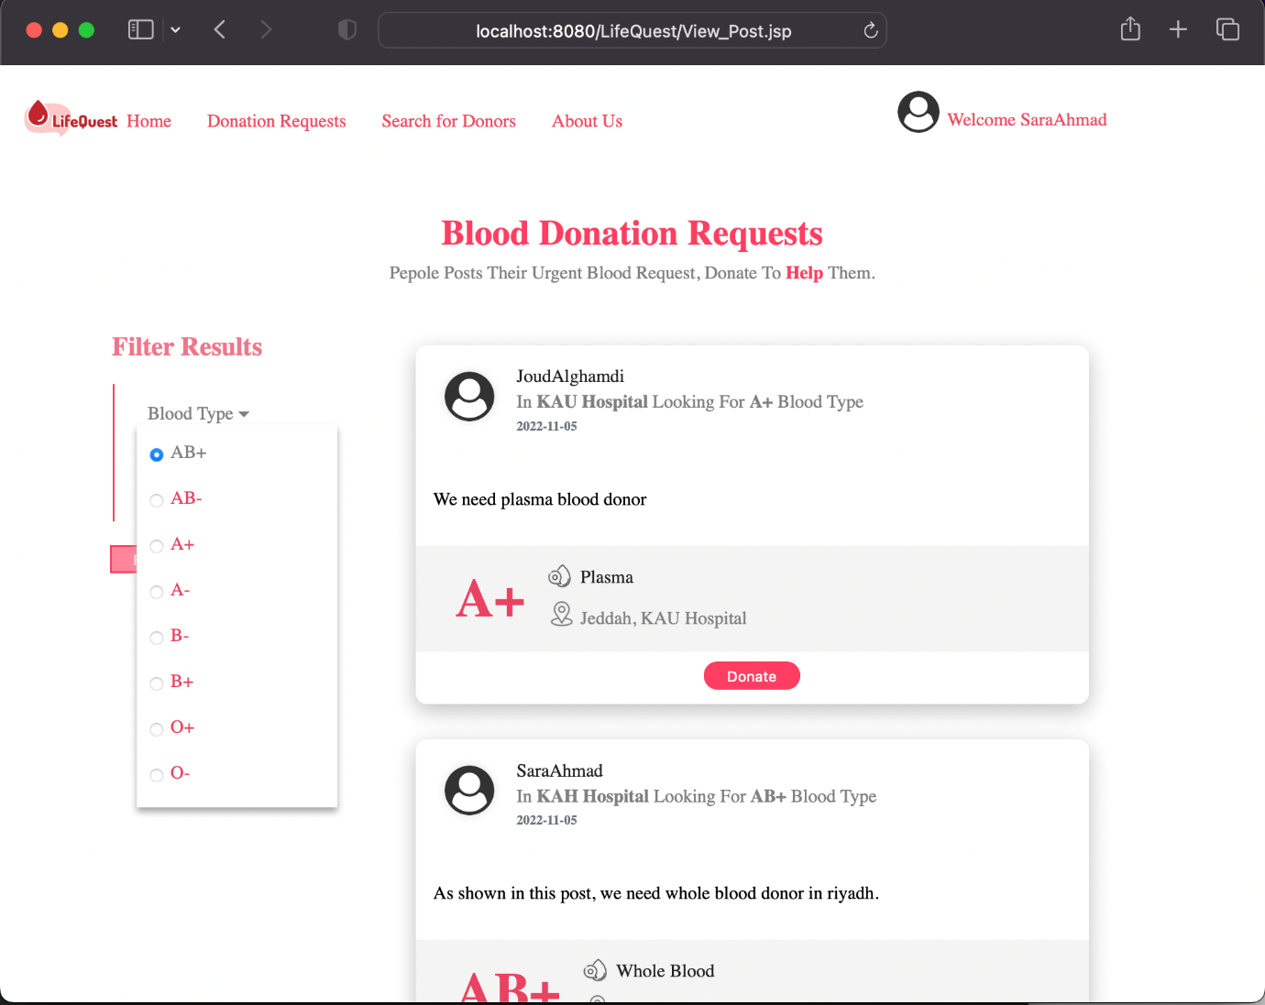

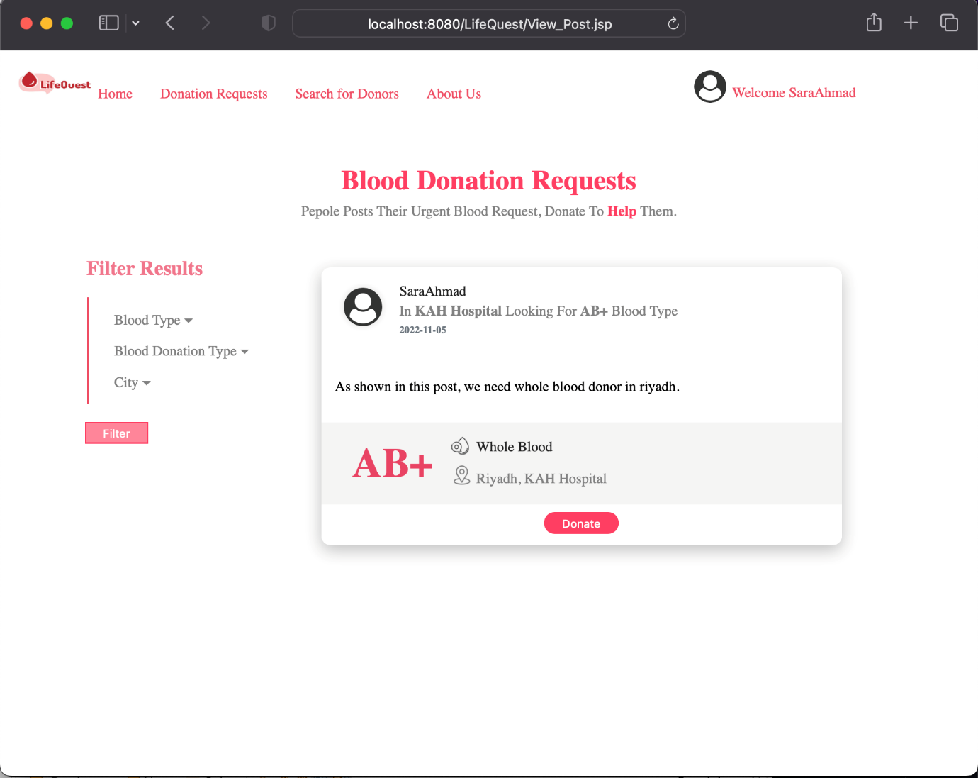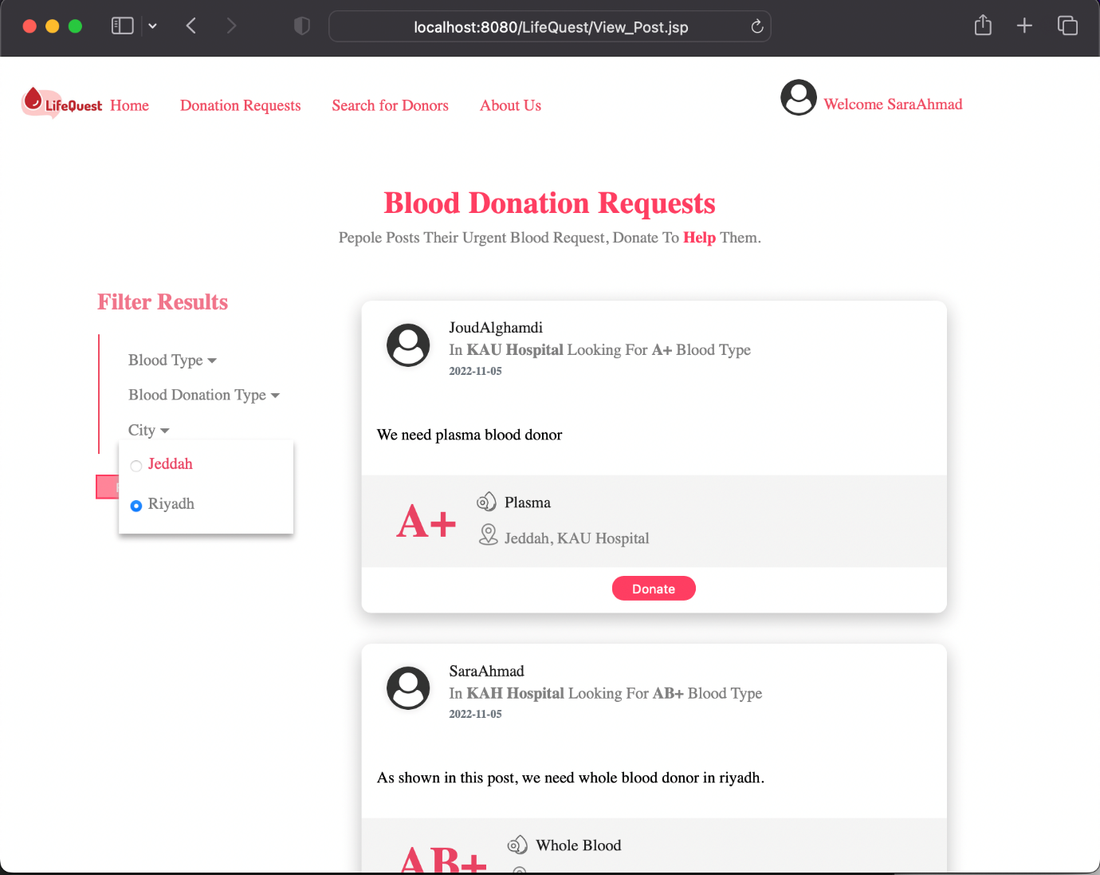

Update Account

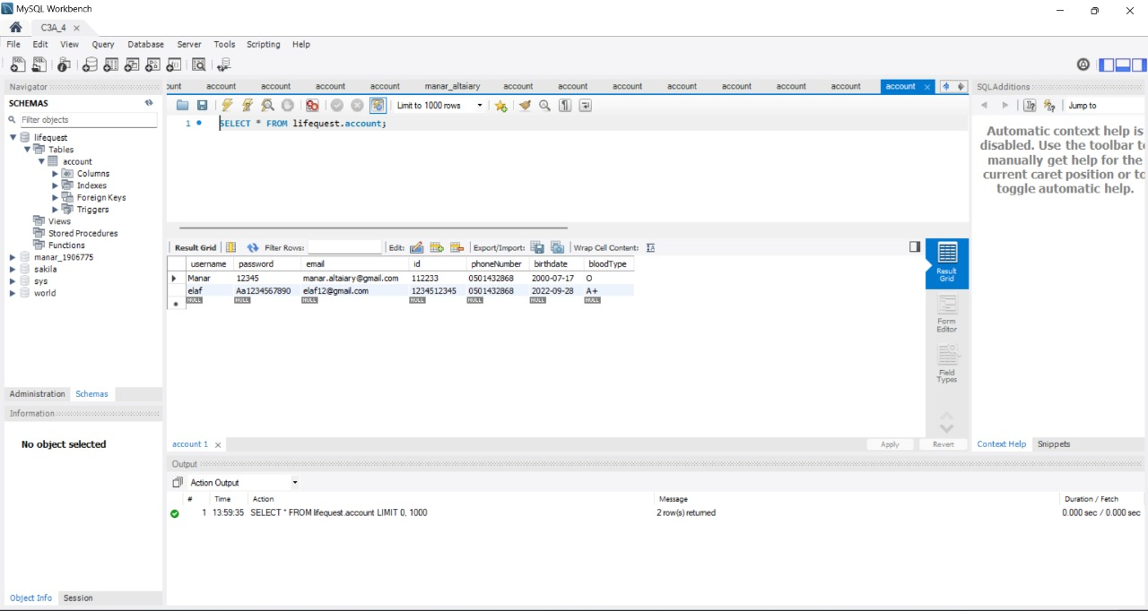

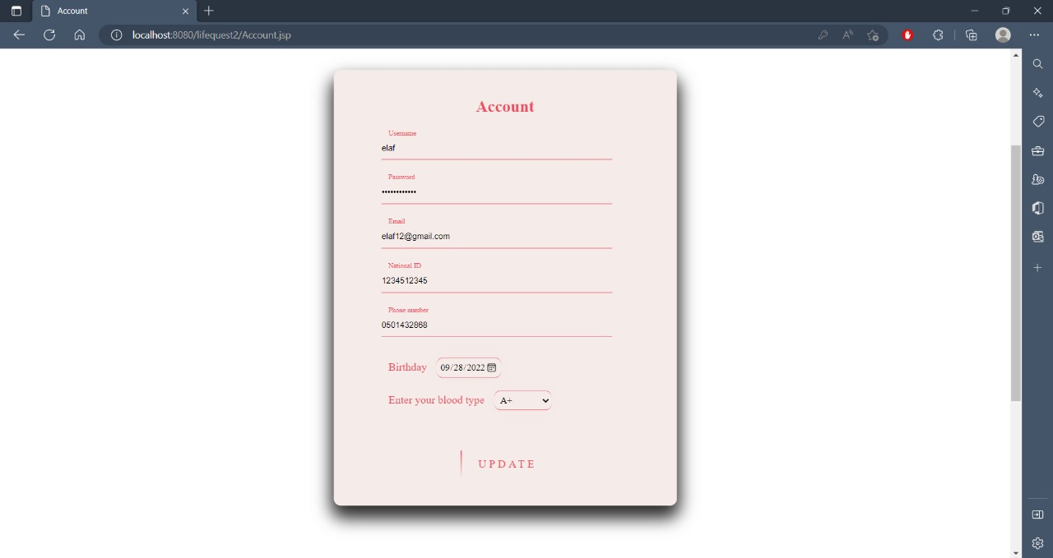

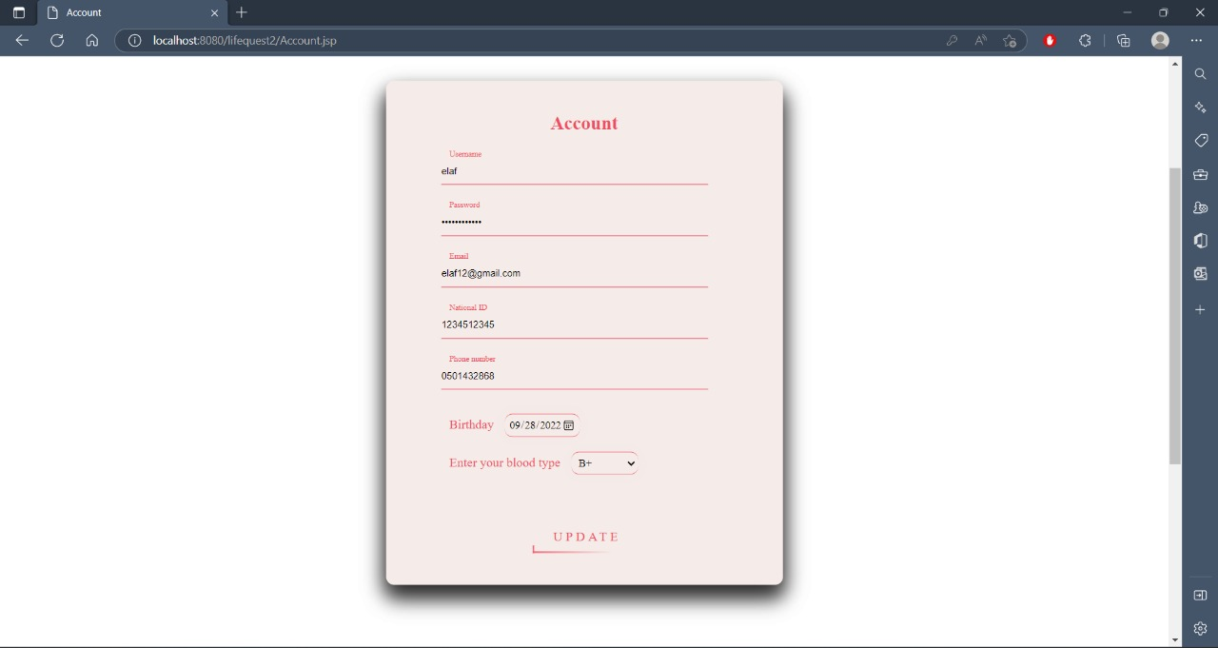

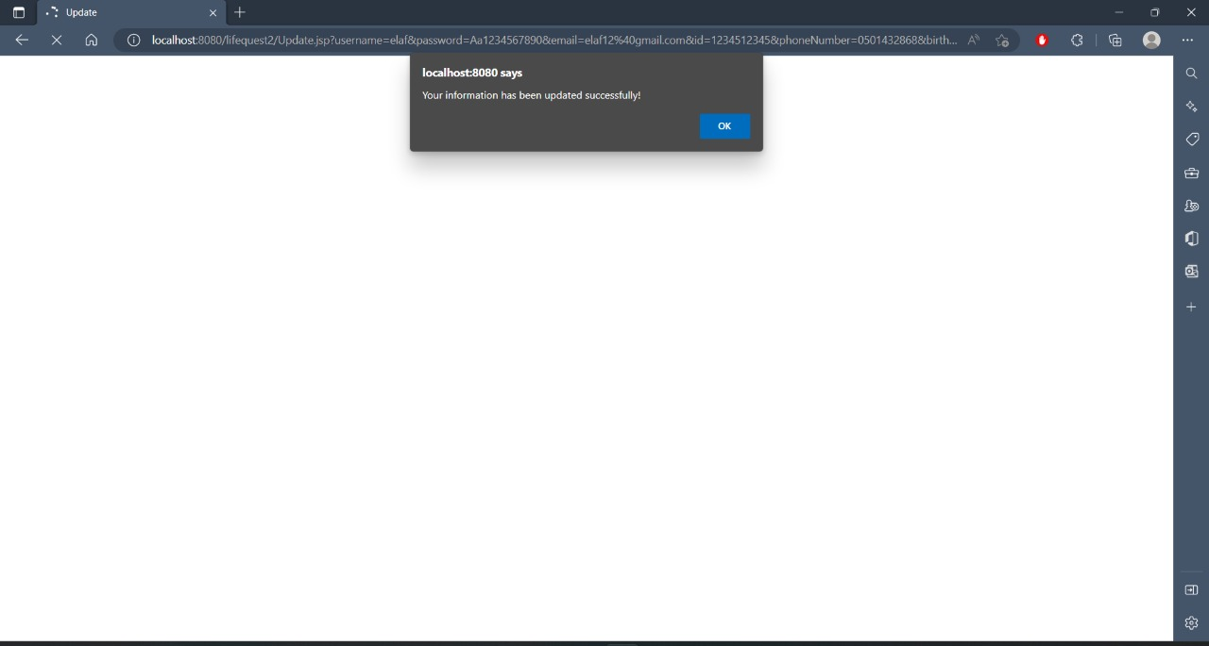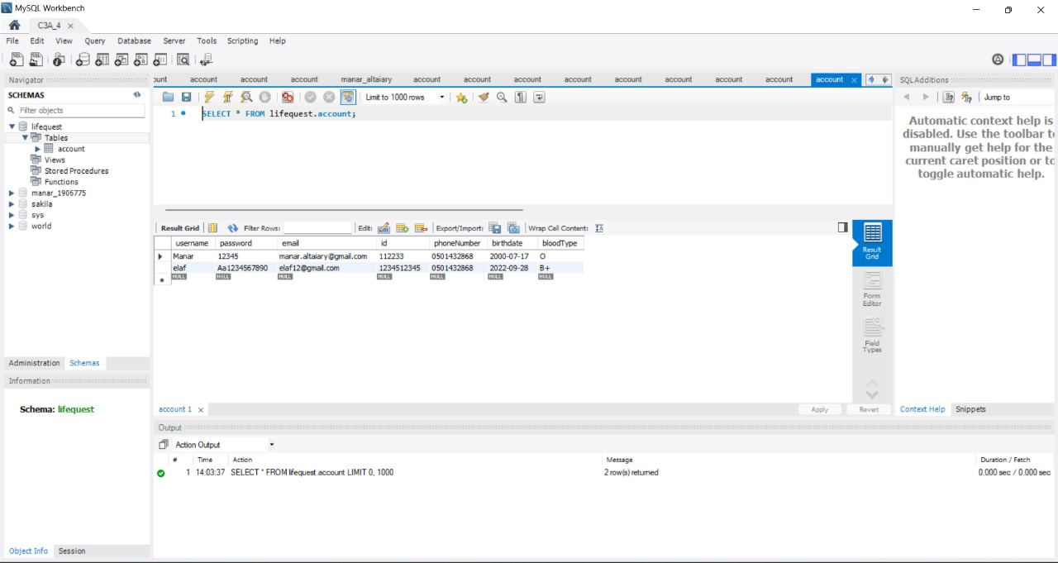

Tools used

For the completion of our project, we utilized some tools that helped us to manage and facilitate it efficiently.

* Google Drive- Google Documents:

To collaborate on drafting our documents and diagrams with real-time updates.

* Microsoft PowerPoint:

It helps us present the work we have done and display it.

* MySQL Workbench:

It helps us to build the database for the system.

* Apache NetBeans:

It helped us to establish a web application page using java classes.

* GitHub:

To enable us to track changes in our code across versions, as well as to provide online access to our code and version history.

* Trello:

It helps us schedule sprints and organize the work into categories like "To Do, Doing, Done"

* Microsoft Word:

To create and collaborate on documents with built-in intelligent features.

* Google meet:

To conduct online meetings and share, edit, and manage files in real time.

Lessons Learned

* Improving out time management skills.
* Learning how to deal and cooperate with team members who have different opinions.
* Building a website from scratch.
* Working in scrum methodology.
* Using MySQL workbench.
* Using JSP technology for developing webpages.
* The application of security guidelines and dependable programming guidelines.
* Developing a secure design and Applying security testing and assurance.

Obstacles

We encountered some difficulties due to our lack of experience in front-end development (HTML, CSS, and JavaScript), and the differences in experience (Logic, backgrounds, and programming skills) for each member.

Furthermore, it was a challenge coordinating long meetings, and also ensuring all our design decisions were correct. Also, the main challenge for us was related to short-term time for developing advanced projects for more than one course during the semester.

Future Work

* Provide the user with the ability to schedule an appointment with the hospital they wish to donate to.
* Give the user the option of posting a donation offer.
* Matching the blood type before sending the notification to the user of the presence of a donor.

Conclusion

In this report, we determine the problem that many people faced when they post their blood donation requests with their information on their social media, and many ignore those posts. One of the main targets of the LifeQuest website is to post these requests in a place where no one will ignore them. Also, LifeQuest is hastening the processes of posting their requests and searching for patients.

LifeQuest is unlike any other website; it must concern one non-functional requirement more than any other non-functional requirement, which is Security. This non-functional requirement will protect all users’ sensitive information that might affect their life.

Finally, LifeQuest follows dependable programming guidelines to improve the Security and reliability of the website.

Tasks distribution

|  |  |
| --- | --- |
| **Student Name** | **Tasks** |
| Elaf Yousef Aloufi | Problem statement, Proposed solution, Approach, Functional requirements, Non-functional requirements, Preliminary risk assessment, Security requirements, Misuse case, Design decisions, Sign Up feature, Update account, Database, Lessons learned, Obstacles, Future work. |
| Manar Mutlaq Altaiary | Introduction, Problem statement, Proposed solution, Functional requirements, Non-functional requirements, Preliminary risk assessment, Security requirements, Design decisions, Tools used, Login feature, home page, Update account. |
| Joud Musharraf Alghamdi | Functional requirements, Non-functional requirements, Preliminary risk assessment, Security requirements, Design risk assessment, Design decisions, Database Design ER model, High-level Prototype, Add Post page, View Post, and filter post page. |
| Shireen Yahya Enani | Abstract, Functional requirements, Non-functional requirements, Preliminary risk assessment, Security requirements, Use case diagram, Design decisions, Conclusion, About us page, Donation instructions page. |

GitHub

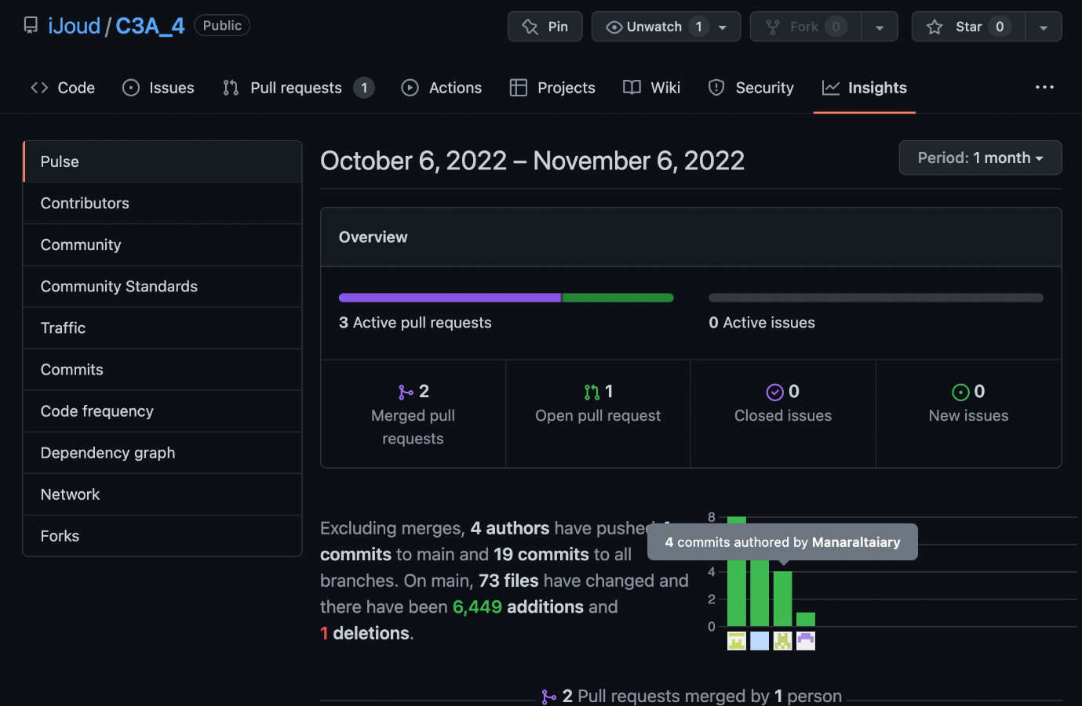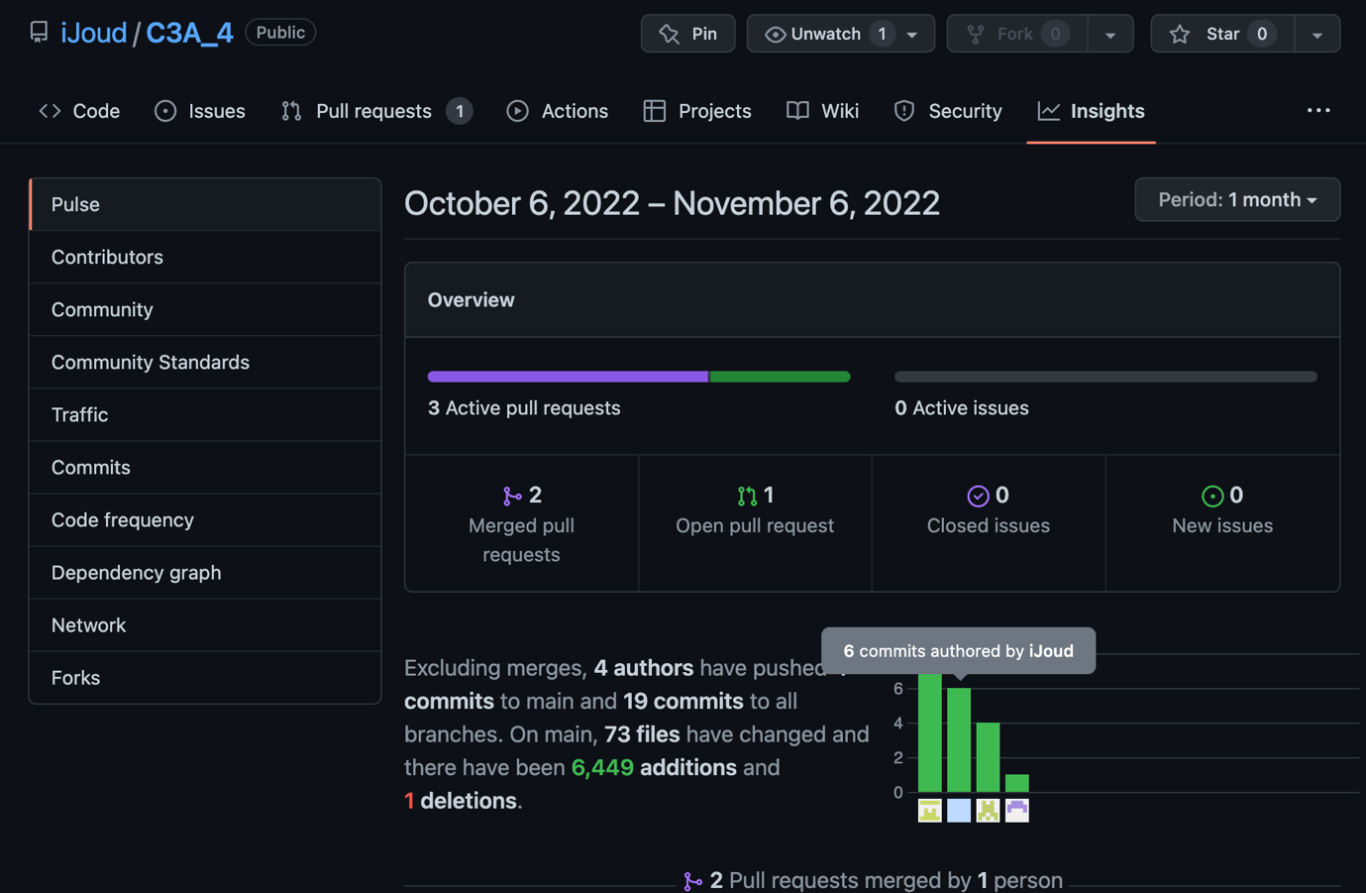

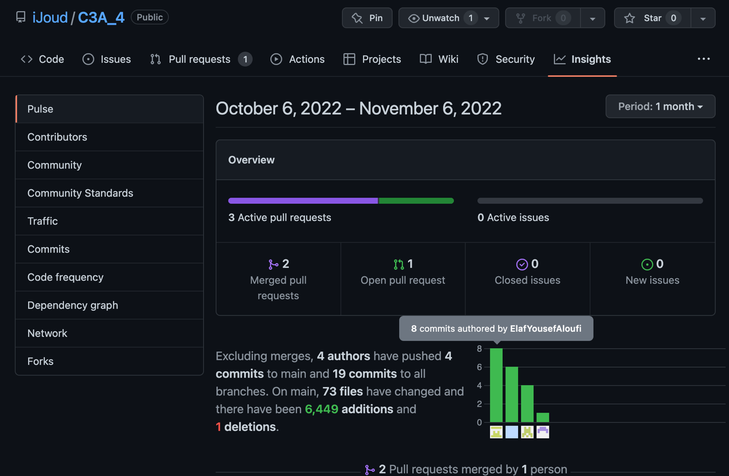

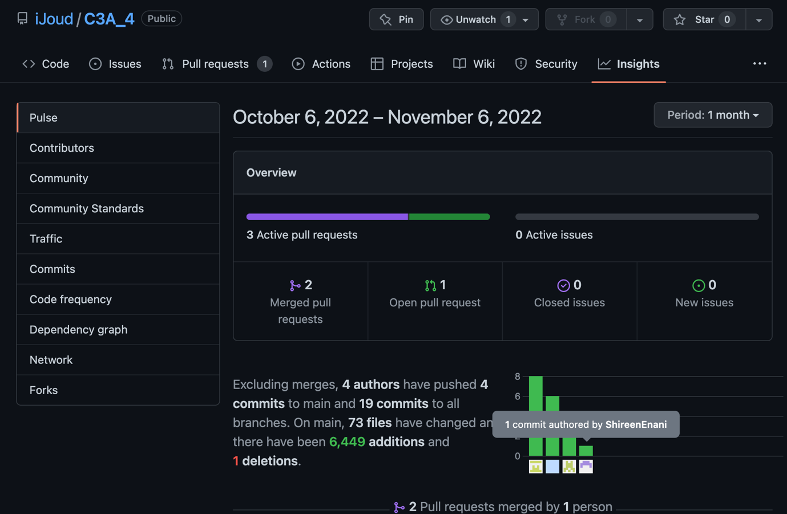

References

|  |  |
| --- | --- |
| [1] | I. Fortinet, “Brute Force Attack,” Fortinet, 2012. [Online]. Available: https://www.fortinet.com/resources/cyberglossary/brute-force-attack. [Accessed 11 10 2022]. |
| [2] | I. Xplore, “DoS Attack and Detection Programming,” IEEE Xplore, 21 09 2009. [Online]. Available: https://ieeexplore.ieee.org/abstract/document/5368799. [Accessed 11 10 2022]. |
| [3] | K. Spett, “SQL Injection,” 2002. [Online]. Available: http://36.92.42.3:8282/EBOOKS/DATA%20BASE/SQLInjectionWhitePaper.pdf. [Accessed 15 10 2022]. |